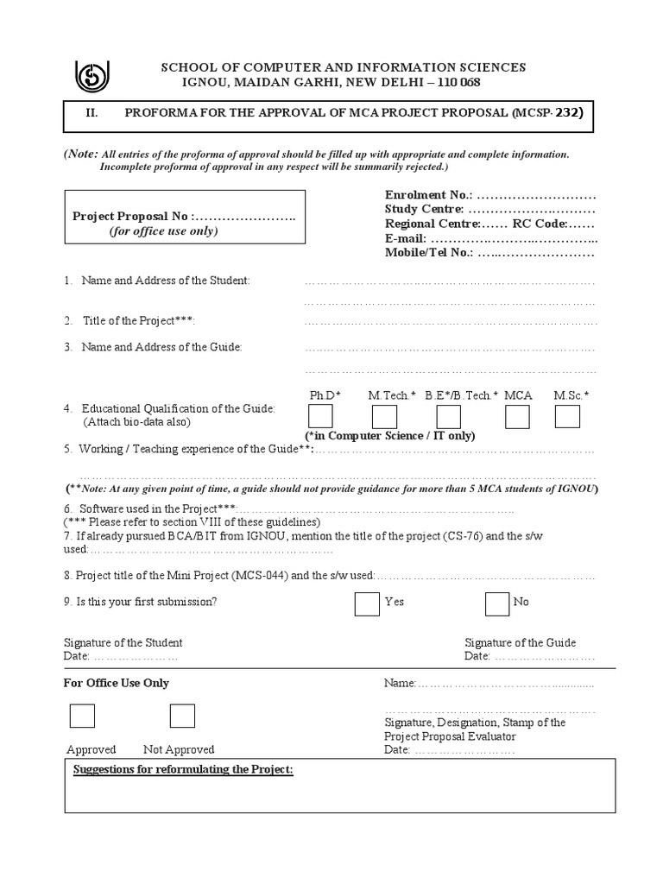

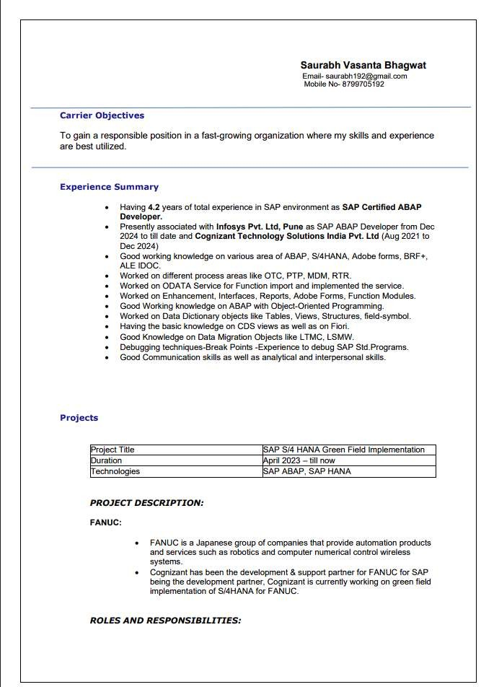

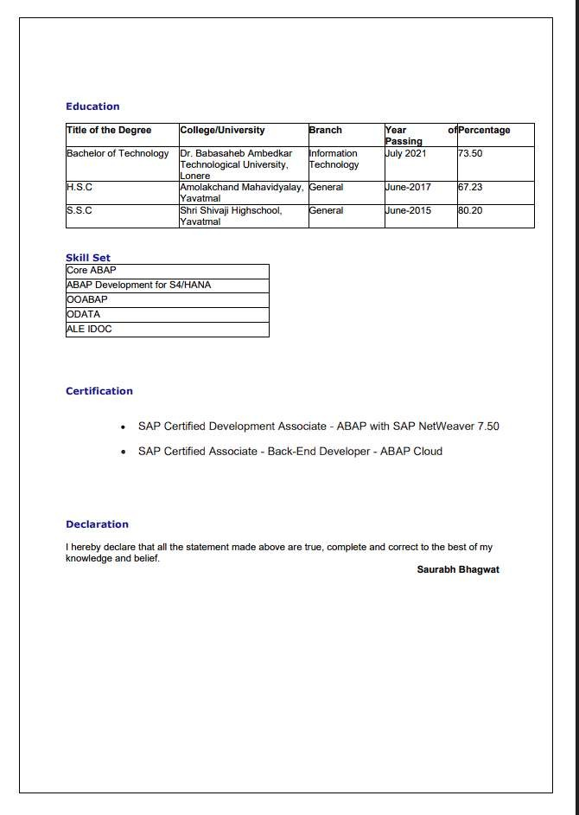



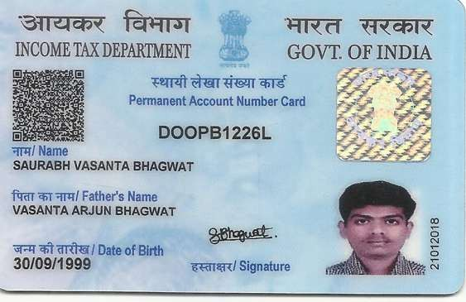



- Introduction
The E-Commerce Platform for Food Order is a web-based application designed to simplify and automate the process of ordering food from restaurants. The system is mainly developed for small and medium-sized restaurants that traditionally depend on phone calls, handwritten notes, or manual methods for receiving and processing customer orders. These traditional methods can lead to order errors, delays, difficulty in managing multiple orders, and problems in maintaining accurate menu and stock information.
The proposed system provides a centralized online platform where customers can browse food items according to different categories, view prices and availability, add items to a shopping cart, select quantities, and place orders conveniently using a mobile phone or computer. After an order is submitted, the system generates a unique order ID and allows customers to view the status of their orders.
The system also provides an Admin module through which restaurant staff can manage food categories, menu items, prices, availability, customer orders, and order status. The administrator can update an order through different stages such as Received, Cooking, Ready, and Delivered. The system can also provide basic sales information and low-stock alerts to support restaurant management.
The application uses HTML5, CSS3 and Bootstrap for the frontend, PHP for backend processing, MySQL as the relational database, and XAMPP as the local development server. The database is designed using relational tables and maintains information related to users, menu items, orders, and order details. The system also incorporates security mechanisms such as authentication, input validation, prepared statements, session management, and access control.
Overall, the project aims to provide a simple, affordable, and user-friendly digital food ordering solution that reduces manual work, improves order accuracy, provides better order management, and enhances convenience for both customers and restaurant staff. The system is designed to run locally using XAMPP, making it suitable for demonstration and implementation without requiring expensive hosting infrastructure.

- System Analysis
System analysis is the process of studying the existing system, identifying its problems and requirements, and designing a suitable solution to meet the needs of users. In the E-Commerce Platform for Food Order, system analysis focuses on understanding the activities involved in food ordering, menu management, order processing, payment, and delivery.
The proposed system is a web-based food ordering application developed to automate the traditional food ordering process. It provides two major types of users: Customers and Administrators. Customers can browse food items, view categories and availability, add items to a cart, place orders, and track the status of their orders. Administrators can manage users, food categories, menu items, orders, payments, deliveries, and reports.
The system stores information in a structured relational database. Important information such as user details, categories, menu items, orders, order details, payments, and delivery notifications is maintained in separate tables. The database design follows normalization principles to reduce data redundancy and maintain data consistency.
- How the online platform for food order helps
The Online Platform for Food Order helps customers and restaurants by converting the traditional food ordering process into a simple and organized web-based system. It reduces manual work and provides a convenient way to manage food orders.
The platform helps in the following ways:
- Easy Menu Browsing
Customers can view food items through different categories along with their prices, descriptions, and availability.
- Convenient Order Placement
Customers can select food items, add them to the shopping cart, modify quantities, and place orders without making phone calls or visiting the restaurant.
- Reduced Order Errors
Since customer orders are entered directly into the system, the chances of errors caused by handwritten notes or telephone communication are reduced.
- Order Status Tracking
Customers can check the progress of their orders. The restaurant can update the order status through stages such as Received, Cooking, Ready, and Delivered.
- Efficient Restaurant Management
Restaurant staff can manage incoming orders through an administrator dashboard and handle menu items, prices, and availability from a centralized system.
- Better Menu and Stock Management
Administrators can add, edit, or remove food items and update their availability when required.
- Organized Data Management
Customer, menu, order, order-detail, payment, and delivery-related information can be stored systematically in the database.
- Reports and Monitoring
The system can provide basic sales information and low-stock alerts, helping restaurant staff monitor their daily operations.
- Improved Customer Convenience
The platform can be accessed through a mobile phone, tablet, or computer, making food ordering more convenient for customers.
- Reduced Manual Work
The system automates several activities involved in food ordering and order management, allowing restaurant staff to handle orders more efficiently.
Overall, the platform provides a simple, organized, and cost-effective solution for digital food ordering. It improves communication between customers and restaurant staff while reducing dependence on traditional manual order-processing methods.
- What the User needs
The users of the E-Commerce Platform for Food Order need a simple and convenient system that makes food ordering and restaurant management easier. The main user requirements identified for the proposed system are:
- Easy menu access: Customers need to view food items, categories, prices, descriptions, and availability.
- Easy ordering: Customers should be able to select food items, add them to a cart, change quantities, and place orders.
- Order information: Customers need confirmation and a unique order ID after placing an order.
- Order tracking: Customers need to know the current status of their order, such as Received, Cooking, Ready, and Delivered.
- Customer information management: The system should allow users to provide and manage details such as name, phone number, and delivery address.
- Admin management: Restaurant staff need a dashboard to view and manage incoming orders.
- Menu management: Administrators need to add, edit, delete, and update food items, prices, and availability.
- Category management: Administrators need to organize food items into appropriate categories.
- Reports: Restaurant staff need basic sales information and low-stock alerts for better management.
- Security: Users need secure login, session management, input validation, and protection of stored information.
- Accessibility: The platform should be usable through mobile phones, tablets, and computers.
Thus, the primary need of users is a user-friendly, secure, and efficient online platform that simplifies food ordering for customers and provides centralized management facilities for restaurant staff.
  - Identification of Need
The need for the E-Commerce Platform for Food Order arises from the limitations of traditional food ordering methods used by small and medium-sized restaurants. In many cases, customers place orders through telephone calls, physical visits, or other manual methods. Restaurant staff must record customer requirements manually and communicate orders to the kitchen. This process can become difficult to manage, especially when there are multiple orders during busy hours.
The existing manual approach may result in incorrect orders, duplicate entries, delays in order processing, and difficulty in maintaining customer and order records. Customers may also have limited information about food availability, order confirmation, and the status of their orders. Restaurant owners and staff may face difficulties in monitoring menu items, stock availability, daily sales, and order information.
Therefore, there is a need for a centralized and automated food ordering system that can provide a simple interface for customers and an effective management system for restaurant staff. The proposed platform allows customers to browse categorized menus, select food items, add them to a cart, place orders, and track order status. At the same time, administrators can manage menu items, categories, customer orders, order status, payments, deliveries, and basic reports.
The system also provides a structured relational database for maintaining user, menu, order, order-detail, payment, and delivery-related information. This reduces dependence on manual records and helps maintain organized and consistent data.
Thus, the identified need is for a simple, user-friendly, secure, and cost-effective digital food ordering platform that can reduce manual work, minimize order-processing errors, improve customer convenience, and help restaurants manage their daily food-ordering activities more efficiently.
  - Project Planning and Project Scheduling (PERT Chart and Gantt Chart both)
Project planning and scheduling are important activities for the successful development of the E-Commerce Platform for Food Order.

- PERT Chart
PERT (Program Evaluation and Review Technique) is a project management technique used to plan, schedule, and control project activities.
A PERT Chart represents the sequence, dependency, and relationship between different activities of a project. It helps identify which activities must be completed before other activities can begin and helps in monitoring the overall progress of the project.

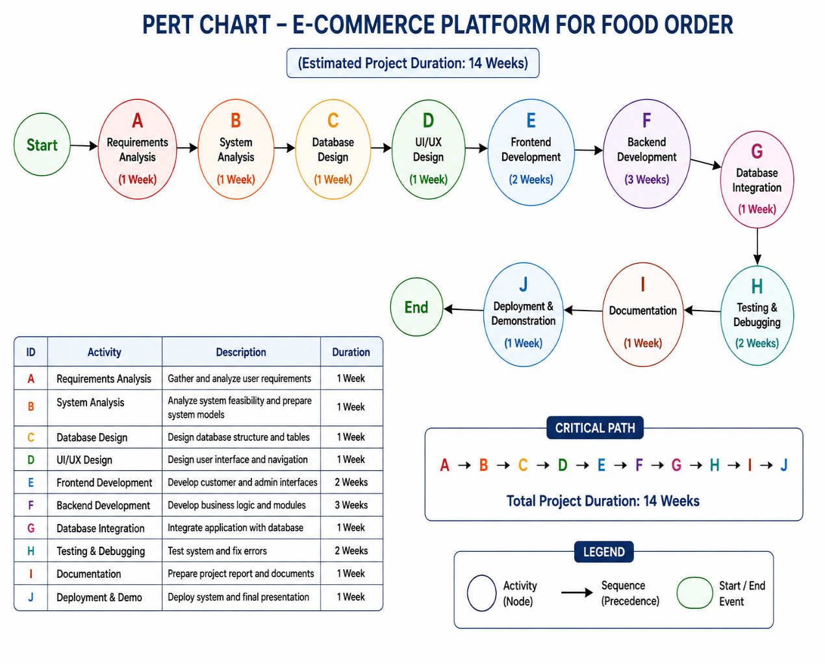

]

- Gantt Chart
A Gantt Chart is a project management tool used to plan and schedule project activities over a specific period of time.
It represents project activities in the form of horizontal bars against a timeline. The length of each bar shows the duration of an activity, making it easy to understand when an activity starts, when it ends, and how different activities are scheduled.

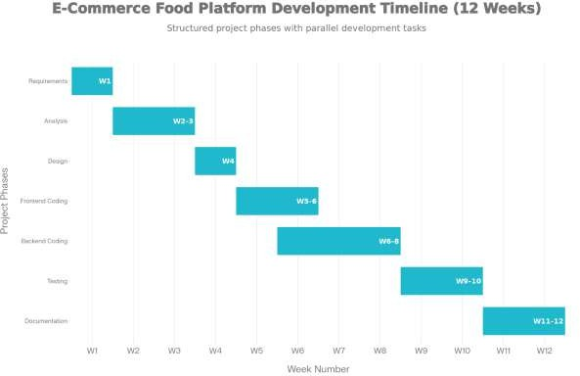

  - Software Requirement Specification (SRS)
Software Requirement Specification (SRS) is a document that describes the functional and non-functional requirements of the proposed software system. It defines what the system should do, how users will interact with it, and the basic requirements needed for its development.
The SRS for the E-Commerce Platform for Food Order defines the requirements for customers and administrators. The system is designed to provide online food browsing, ordering, order management, menu management, and order status tracking.
- Purpose
The main purpose of the system is to provide a web-based platform through which customers can browse food items, place orders, and check order status. It also provides restaurant administrators with facilities to manage menus, orders, stock availability, and basic reports.
The system aims to reduce the problems associated with phone-based and manual food ordering, such as incorrect orders, delays, duplicate entries, and difficulty in tracking orders.
- Scope
The system provides the following major facilities:
- Customer registration and login.
- Browsing food items by category.
- Viewing food prices and availability.
- Adding food items to a shopping cart.
- Changing item quantities.
- Placing food orders.
- Viewing order history and order status.
- Administrator login and dashboard.
- Adding, editing, and managing food items.
- Managing food categories.
- Managing customer orders.
- Updating order status.
- Viewing sales information and low-stock information.
Functional Requirements:

Customer Requirements
The customer module shall provide the following functions:
- Customers should be able to register and log in.
- Customers should be able to browse food items by category.
- Customers should be able to view food name, description, price, and availability.
- Customers should be able to add items to the cart.
- Customers should be able to change the quantity of items.
- The system should automatically calculate the order total.
- Customers should be able to provide their name, phone number, and delivery address.
- Customers should be able to submit an order.
- The system should generate an order identification number.
- Customers should be able to view their order history and current order status.

Administrator Requirements
The administrator module shall provide the following functions:
- Administrator should be able to log in securely.
- Administrator should be able to access the dashboard.
- Administrator should be able to view incoming orders.
- Administrator should be able to update order status.
- Administrator should be able to add, edit, and delete food items.
- Administrator should be able to update food prices and availability.
- Administrator should be able to manage food categories.
- Administrator should be able to view sales reports.
- Administrator should be able to identify low-stock items.
Non-Functional Requirements:
- Performance
The system should provide fast response and should load web pages within a reasonable time.
- Security
The system should provide secure login and session management. User input should be validated and the database should be protected against SQL injection.
- Usability
The interface should be simple and easy to understand so that customers can browse the menu and place orders without difficulty.
- Compatibility
The system should work through commonly used web browsers such as Google Chrome and Mozilla Firefox.
- Responsiveness
The web interface should be responsive and usable on different screen sizes, including computers, tablets, and mobile devices.
- Reliability
The system should store customer, menu, and order information properly and should maintain accurate order records.
Hardware Requirements
The basic hardware requirements for developing and running the system are:
- Computer or laptop.
- Minimum 4 GB RAM.
- Sufficient hard-disk storage.
- Keyboard and mouse.
- Internet connection where required.
- Display monitor.

- Software Requirements
The project document specifies the following software and technologies:
Software/Technology | Requirement
Operating Environment | Windows/local development environment
Frontend | HTML5, CSS3, Bootstrap
Backend | PHP 8.0/8.2
Database | MySQL 8.0
Web Server | Apache through XAMPP
Development Tool | Visual Studio Code
Browser | Google Chrome / Mozilla Firefox
These technologies are specified in the project document for implementation of the proposed system.
- Database Requirements
The system requires a database for storing and managing application information. The major database tables identified in the project are:
- Users – stores customer information.
- Admin – stores administrator information.
- Category – stores food categories.
- Menu – stores food item details.
- Order – stores order information.
- Order Details – stores individual items included in an order.
- Payment – stores payment-related information.
- Delivery – stores delivery-related information.
- Security Requirements
The system should provide basic security mechanisms such as:
- User authentication.
- Secure password handling.
- Session management.
- Input validation.
- Prepared database statements.
- Access control for administrator functions.
- Validation of uploaded files where applicable.
- Proper error handling.
- Regular database backup.
- Validation of orders and order status changes.
These mechanisms help protect user information and prevent unauthorized access to the system.
- System Constraints
The proposed system has some limitations:
- The initial implementation is designed for a local XAMPP environment.
- Advanced online payment functionality may be added in future.
- Real-time GPS delivery tracking is considered a future enhancement.
- Mobile application support is planned for future development.
- Multi-restaurant support is also considered for future enhancement.

  - Software Engineering Paradigm applied
The Agile Software Development Paradigm is applied in the development of the E-Commerce Platform for Food Order.
Agile is an iterative and flexible software development approach in which the system is developed in smaller stages. The requirements and functionality of the system are reviewed regularly, and improvements can be made during the development process.
Agile Methodology in the Proposed System
The Agile approach is suitable for this project because the food ordering system contains several independent modules such as User, Admin, Category, Menu, Order, Order Details, Payment, and Delivery.
The project can be developed and tested in different stages:
- Requirement Analysis – Identify the requirements of customers and administrators.
- System Design – Design the system architecture, database, DFD, ER diagram, and UML diagrams.
- Module Development – Develop different modules such as User, Admin, Menu, and Order.
- Testing – Test each module and identify errors.
- Integration – Integrate the completed modules into a single system.
- Feedback and Improvement – Review the system and make necessary improvements.
- Final Deployment – Prepare the completed system for demonstration and use.

Advantages of Agile for This Project
- Allows development in smaller stages.
- Makes it easier to identify and correct errors.
- Supports changes in requirements.
- Allows regular testing and improvement.
- Helps in developing different modules independently.
- Provides continuous feedback during development.
- Makes project progress easier to monitor.
The Agile paradigm provides a flexible and systematic approach for developing the Food Ordering E-Commerce Platform. It supports iterative development, continuous testing, and improvement of the system throughout the project lifecycle.
  - Data Models
Data Flow Diagrams
A Data Flow Diagram (DFD) is a graphical representation that shows how data moves through a system. It represents the external entities, processes, data stores, and data flows involved in the system.
For the E-Commerce Platform for Food Order, DFDs are used to describe the flow of information between customers, administrators, system processes, and databases.
- DFD Level 0 – Context Diagram
DFD Level 0 provides a high-level view of the entire food ordering system. It represents the system as a single process and shows its interaction with the main external entities.
External Entities:
- Customer
- Admin
Main Data Flow
- Customer sends menu requests and order details to the system.
- System provides menu information, order confirmation, and order status to the customer.
- Admin sends menu and order management information to the system.
- System provides order and management information to the admin.
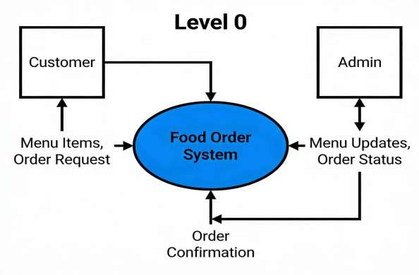

The Level 0 DFD shows that the Customer interacts with the system to browse food and place orders, while the admin manages menu and order information.
- DFD Level 1
DFD Level 1 provides more detail by dividing the main system into major processes.
The main processes identified in the project document are:
- View Menu
- Place Order
- Manage Orders
The major data stores are:
- Menu Database
- Orders Database
- Users Database

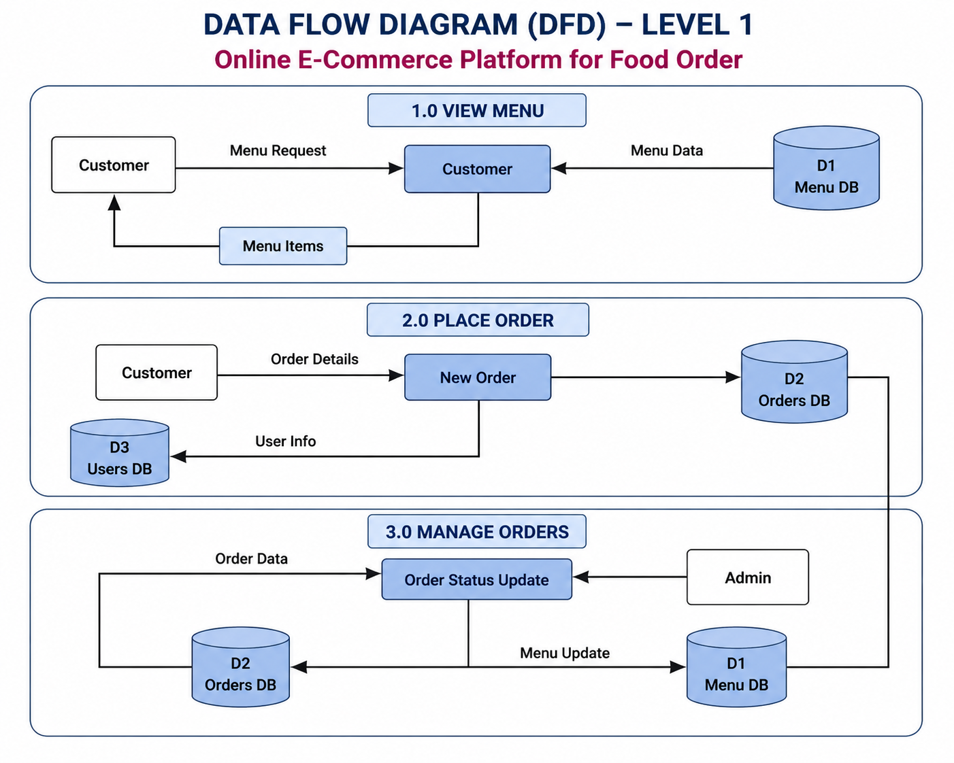

The Level 1 DFD breaks the overall system into individual processes and shows their interaction with the Menu, Orders, and Users databases.

DFD Level 2
The uploaded project document specifically describes Level 0 and Level 1 DFDs, but it does not provide detailed Level 2 process descriptions. Therefore, a detailed Level 2 DFD should not be added as document-derived content without defining the additional processes first.

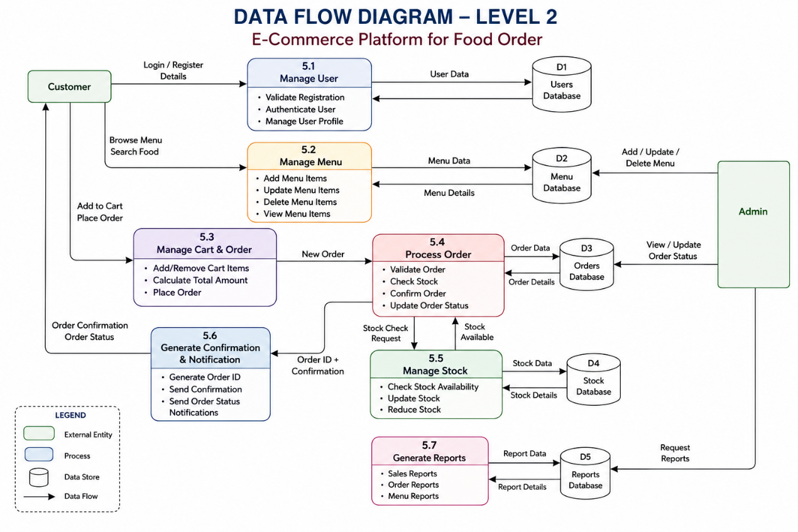

State Diagrams
A State Diagram is a UML diagram that represents the different states of an object and the transitions between those states based on events or actions.
For the E-Commerce Platform for Food Order, the state diagram mainly represents the lifecycle of a customer's food order.
- Received: The system receives and records the customer's order.
- Cooking: The restaurant starts preparing the ordered food.
- Ready: The food is prepared and ready for delivery.
- Delivered: The order reaches the customer and the order process is completed.
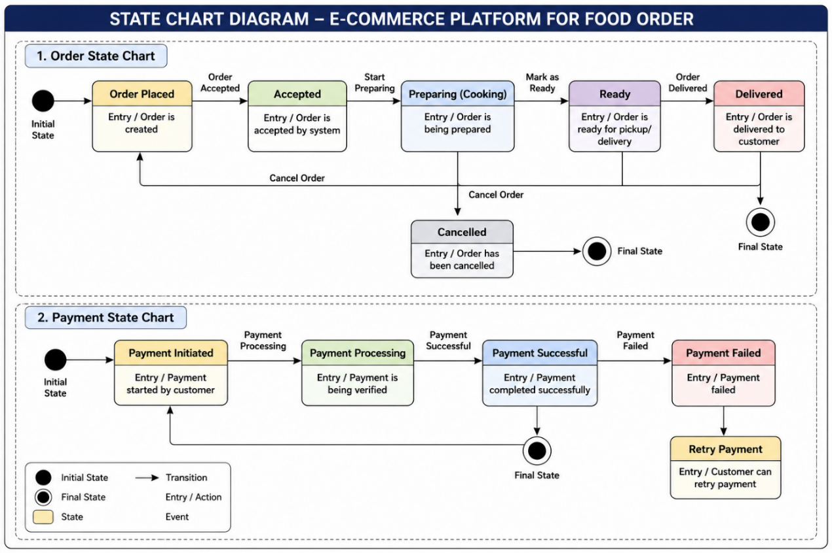
Thus, the state diagram clearly shows the lifecycle of a food order from the time it is placed until it is delivered. The four order statuses are consistent with the status values specified in the project document.

Entity Relationship Diagram (ERD)
An Entity Relationship Diagram (ERD) is a graphical representation of the database structure of a system. It shows the entities, their attributes, primary keys, foreign keys, and relationships between different entities.
For the E-Commerce Platform for Food Order, the major entities are Users, Admin, Category, Menu, Order, Order Details, Payment, and Delivery.

The Users entity stores customer information. A customer can place an Order, and each order contains one or more Order Details. Order Details identify the food items selected from the Menu entity.
The Menu entity contains food item information and is organized using the Category entity. The Payment entity stores payment-related information associated with an order, while the Delivery entity stores delivery-related information.
The admin entity represents the restaurant administrator who manages menu items, categories, and customer orders.
This ERD provides the basic database structure required for the food ordering system and shows how the major entities are connected.

Use case Diagram

A Use Case Diagram is a UML diagram that shows the interaction between the users (actors) and the functions provided by a software system. It helps to identify what different users can do within the system.
For the E-Commerce Platform for Food Order, the main actors are:
- Customer
- Admin

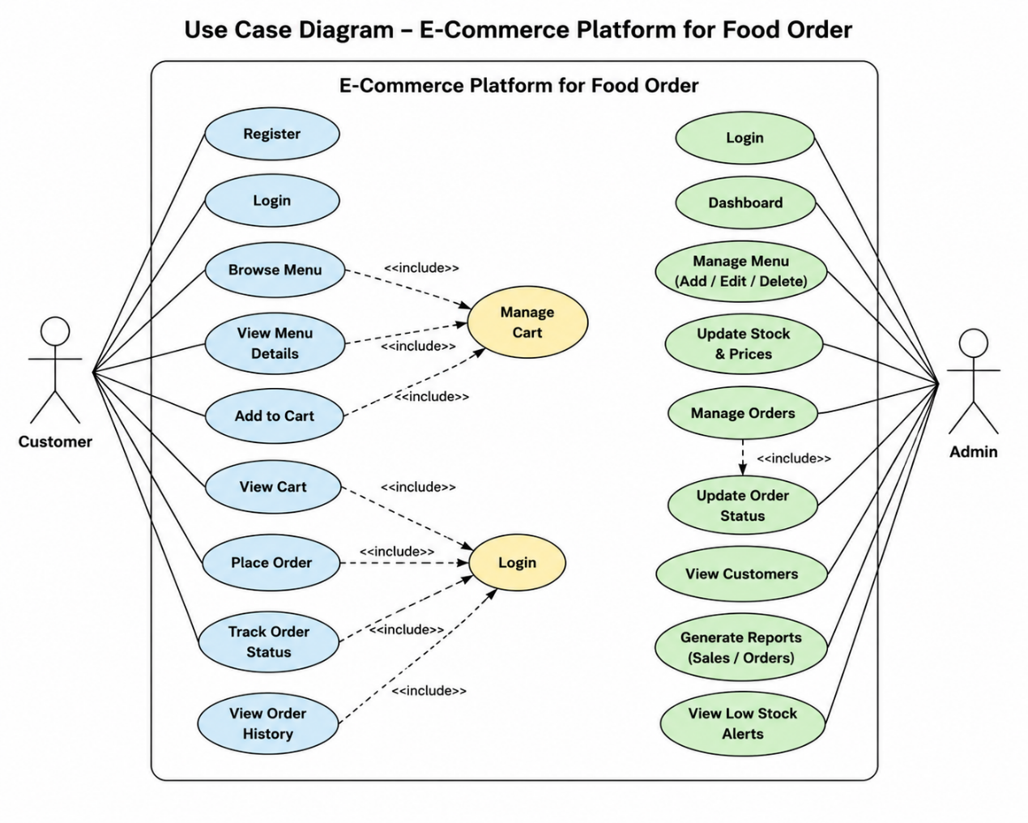

Customer Use Cases
The Customer interacts with the system to:
- Register/Login – Create an account and securely access the system.
- Browse Menu – View available food items and categories.
- View Food Details – View food name, description, price, and availability.
- Add Items to Cart – Select food items for ordering.
- Modify Cart – Change item quantities or remove items.
- Place Order – Provide required details and submit the order.
- View Order History – View previously placed orders.
- Track Order Status – Check whether the order is Received, Cooking, Ready, or Delivered.
Admin Use Cases
The admin interacts with the system to:
- Admin Login – Securely access administrative functions.
- Manage Users – Manage customer information.
- Manage Categories – Add and manage food categories.
- Manage Menu – Add, edit, delete, and update food items, prices, and availability.
- Manage Orders – View and process customer orders.
- Update Order Status – Update orders through Received, Cooking, Ready, and Delivered.
- Manage Payments – Manage payment-related information.
- Manage Delivery – Manage delivery-related information.
- View Reports – View sales information and low-stock information.

The Use Case Diagram shows that the Customer mainly uses the system for browsing and ordering food, while the admin manages the operational activities of the platform. This provides a clear representation of the interaction between the system and its users.

System Design
System design is the process of defining the structure, components, database, interfaces, and interaction of the proposed software system. It converts the requirements identified during system analysis into a detailed design that can be used for implementation.
The E-Commerce Platform for Food Order is designed as a web-based application that allows customers to browse food items, place orders, and check order status. It also provides administrators with facilities to manage users, categories, menu items, orders, payments, delivery, and reports.
System Architecture
The system follows a web-based architecture consisting of three main parts:
- Presentation Layer – Provides the user interface using HTML, CSS, and Bootstrap.
- Application Layer – Handles business logic and user requests using PHP.
- Database Layer – Stores and manages system information using MySQL.
The project document specifies PHP 8.0/8.2, HTML5, CSS3, Bootstrap, MySQL 8.0, and XAMPP as the main technologies and development environment.

Modularization Details
The system is divided into the following major modules:
- User Module
Handles customer registration, login, profile information, and order history.
- Admin Module
Allows administrators to manage users, categories, menu items, orders, payments, delivery, and reports.
- Category Module
Manages food categories and organizes menu items.
- Menu Module
Stores and manages food item names, descriptions, prices, images, and availability.
- Order Module
Handles order placement, order totals, order IDs, and order status.
- Order Details Module
Stores individual food items, quantities, prices, and subtotals belonging to an order.
- Payment Module
Maintains payment-related information and payment status.
- Delivery Module
Maintains delivery-related information and delivery status.
These modules are identified in the project document as the main functional modules of the system.

  - Data integrity and Constraints
Data integrity ensures that the data stored in the Food Ordering E-Commerce Platform remains accurate, consistent, complete, and reliable. Constraints are applied to the database tables to prevent invalid or incorrect data from being entered into the system.
- Primary Key Constraint
A Primary Key uniquely identifies each record in a table. It does not allow duplicate or NULL values.
Examples:
- user_id in the Users table
- category_id in the Category table
- item_id in the Menu table
- order_id in the Order table
- payment_id in the Payment table
- Foreign Key Constraint
A Foreign Key establishes a relationship between two tables and maintains referential integrity.
Examples:
- category_id in the Menu table refers to the Category table.
- user_id in the Order table refers to the Users table.
- order_id in the Order Details table refers to the Order table.
- item_id in the Order Details table refers to the Menu table.
This prevents records from referring to non-existing users, orders, categories, or menu items.
- NOT NULL Constraint
The NOT NULL constraint ensures that important fields cannot be left empty.
For example:
- Customer name
- Customer phone number
- Item name
- Food price
- Order user ID
This ensures that essential information is available for processing orders.
- UNIQUE Constraint
The UNIQUE constraint prevents duplicate values in fields that should contain unique information.
For example, a user's email address can be kept unique so that the same email cannot be registered multiple times.
- CHECK Constraint
The CHECK constraint ensures that values satisfy a specified condition.
Examples:
- Food price should not be negative.
- Food quantity should be greater than zero.
- Order amount should not be negative.
- Availability should contain a valid value.
- DEFAULT Constraint
The DEFAULT constraint automatically provides a value when the user does not enter one.
For example:
- Order status can be set to receive by default.
- Order date can be automatically set to the current date and time.
- Notification status can be set to UNREAD by default.
- Data Type Constraints
Appropriate data types are used for different types of information.
Examples:
- INT for IDs
- VARCHAR for names, phone numbers, and addresses
- DECIMAL for food prices and monetary values
- TEXT for descriptions and messages
- BOOLEAN for availability
- TIMESTAMP for dates and times
Using suitable data types helps prevent invalid data from being stored.
- Referential Integrity
Referential integrity ensures that relationships between tables remain valid. For example, an order should belong to an existing user, and order details should refer to an existing order and menu item.
- Data Validation
The application validates user input before storing it in the database. It helps prevent incomplete, invalid, or inappropriate information from entering the system.
- Security and Data Integrity
Prepared statements, authentication, session management, access control, and input validation are used to protect database information. These mechanisms help prevent unauthorized changes and common database attacks such as SQL injection.
  - Database Design, Procedural Design/ Object oriented Design
The database is designed to store the information required for customers, food items, orders, payments, and delivery. Database design is the process of organizing and storing the data required by the Food Ordering E-Commerce Platform. The system uses a relational database to store customer, menu, order, payment, and delivery information. The database is designed using related tables so that data can be stored and retrieved efficiently. The major entities/tables are:
- Users
- Admin
- Category
- Menu
- Order
- Order Details
- Payment
- Delivery
- Users Table
The Users table stores information about customers who register and use the food ordering platform.
Main information includes:
- User ID
- Name
- Email
- Password
- Phone number
- Address
- Registration details
The user_id uniquely identifies each customer.
- Admin Table
The admin table stores administrator information. It is used for secure access to administrative functions.
Main functions include:
- Admin login
- User management
- Menu management
- Order management
- Payment and delivery management
- Report management
- Category Table
The Category table stores food categories used to organize menu items.
Examples of categories include:
- Snacks
- Main Course
- Beverages
- Desserts
Each category has a unique category_id.
- Menu Table
The Menu table stores details of food items available on the platform.
Main fields include:
- item_id
- category_id
- item_name
- description
- price
- image
- availability
The category_id connects each menu item with its category.
- Order Table
The Order table stores information about orders placed by customers.
Main information includes:
- Order ID
- User ID
- Customer name
- Customer phone
- Delivery address
- Total amount
- Order date
- Order status
The order status can move through Received, Cooking, Ready, and Delivered.
- Order Details Table
The Order Details table stores the individual food items included in an order.
Main information includes:
- Order detail ID
- Order ID
- Item ID
- Quantity
- Price
- Subtotal
This table allows one order to contain multiple food items.
- Payment Table
The Payment table stores payment-related information associated with an order.
It can contain information such as:
- Payment ID
- Order ID
- Payment method
- Payment amount
- Payment status
- Payment date
- Delivery Table
The Delivery table stores delivery-related information.
It helps the administrator manage and track the delivery status of customer orders.
Database Relationships
The main relationships between the tables are:
- One User can place many Orders.
- One Category can contain many Menu Items.
- One Order can contain many Order Details.
- One Menu Item can appear in many Order Details.
- An Order is associated with payment information.
- An Order is associated with delivery information.
The database design provides a structured way to store and manage information required by the food ordering platform. Relationships between tables reduce duplicate data and help maintain data integrity and consistency.
The entities are connected through primary keys and foreign-key relationships to maintain relationships between customers, orders, menu items, and related information.

Procedural Design / Object-Oriented Design
The Food Ordering E-Commerce Platform can be designed using a structured procedural approach as well as an object-oriented approach. The design describes how the system processes customer orders and how different modules interact with each other.
- Procedural Design
Procedural design represents the system as a sequence of processes or procedures. Each process performs a specific task and passes the required information to the next process.
Main Procedures:
- User Registration/ Login:
The system verifies customer credentials before allowing access to the platform.
- Browse Menu:
The customer selects a category and views available food items.
- Cart Management:
The customer adds food items to the cart and changes quantities or removes items.
- Order Processing:
The system calculates the order amount and stores the order information in the database.
- Order Management:
The administrator receives the order and updates its status.
- Delivery Management:
The delivery information is maintained and the order status is updated until delivery is completed.
- Object-Oriented Design
Object-oriented design represents the system using objects and classes. Each class represents a particular entity or function of the food ordering platform.
Main Classes:
User Class
- user_id
- name
- email
- password
- phone
- address
Admin Class
- admin_id
- name
- email
- password
Category Class
- category_id
- category_name
Menu Class
- item_id
- category_id
- item_name
- description
- price
- availability
Order Class
- order_id
- user_id
- total_amount
- order_date
- status
OrderDetails Class
- order_detail_id
- order_id
- item_id
- quantity
- price
- subtotal
Payment Class
- payment_id
- order_id
- payment_method
- amount
- status
Delivery Class
- delivery_id
- order_id
- delivery_status
- delivery_information

Advantages of the Design
- Separates the system into manageable modules.
- Makes the system easier to understand and maintain.
- Allows customer, menu, order, payment, and delivery functions to be handled separately.
- Reduces unnecessary duplication of functionality.
- Makes future modifications and enhancements easier.
The procedural design describes the sequence of activities involved in processing a food order, while the object-oriented design represents the system through classes and objects. Both approaches provide a clear structure for developing and maintaining the Food Ordering E-Commerce Platform.
  - User Interface Design
User Interface (UI) Design defines how users interact with the Food Ordering E-Commerce Platform. The interface is designed to be simple, clear, responsive, and easy to use. The system provides separate interfaces for Customers and Administrators.
The frontend of the system is developed using HTML5, CSS3, and Bootstrap. The interface allows customers to browse food items, manage their cart, place orders, and check order status. The administrator interface provides functions for managing users, categories, menu items, orders, payments, delivery, and reports.
- Customer Interface
The customer interface provides the following screens:

a) Login and Registration Page
The login page allows registered customers to enter their email/username and password. New customers can use the registration page to create an account.
Main elements:
- Username/Email
- Password
- Login button
- Registration option

b) Home Page
The home page provides access to the main features of the platform.
Main elements:
- Website name/logo
- Navigation menu
- Food categories
- Available food items
- Search/browse options
- Cart option
- Login/Profile option

c) Menu Page
The menu page displays available food items according to their categories.
Each food item can display:
- Food name
- Description
- Price
- Image
- Availability
- Add to Cart button

d) Shopping Cart
The cart page displays the food items selected by the customer.
The customer can:
- View selected items
- Increase or decrease quantity
- Remove items
- View subtotal and total amount
- Proceed to place the order

e) Order Page
The order page collects the information required to process the order.
The customer provides:
- Name
- Phone number
- Delivery address
- Selected food items
- Total amount
After confirmation, the order is stored in the database.

f) Order Status Page
The customer can view the current status of an order. The system uses the following order stages:
Received → Cooking → Ready → Delivered
This allows the customer to understand the progress of the order.

Administrator Interface
The administrator interface provides a dashboard for managing the food ordering system.

a) Admin Login
The administrator must log in using valid credentials before accessing administrative functions.

b) Admin Dashboard
The dashboard provides access to:
- User management
- Category management
- Menu management
- Order management
- Payment management
- Delivery management
- Reports

c) Menu Management Interface
The administrator can add, edit, or remove food items and update information such as price and availability.

d) Order Management Interface
The administrator can view customer orders and update their status:
Received → Cooking → Ready → Delivered

e) Reports Interface
The administrator can view relevant sales and stock information to support restaurant management.
The User Interface Design provides separate and organized interfaces for customers and administrators. Customers can easily browse the menu, manage their cart, place orders, and track order status, while administrators can manage the main operations of the platform through the dashboard. The use of HTML5, CSS3, and Bootstrap supports a simple and responsive interface.
  - Test cases (Unit Test cases and System Test cases)
Testing is performed to verify that the Food Ordering E-Commerce Platform works according to the specified requirements. Testing is divided into Unit Testing and System Testing.

Unit Test Cases
Unit testing checks individual modules or functions separately. It helps identify errors in a particular module before integrating it with the complete system.
- User registration
- Description: Checks whether a new customer can create an account.
- Input: Valid name, email, phone number and password.
- Expected Result: Customer account is created successfully.
- Registration Validation
- Description: Checks whether required registration fields are validated.
- Input: Registration form with one or more empty required fields.
- Expected Result: Appropriate validation message is displayed.
- User Login
- Description: Checks whether a registered customer can log in.
- Input: Valid email and password.
- Expected Result: Customer is successfully logged in.
- Invalid Login
- Description: Checks login with incorrect credentials.
- Input: Incorrect email or password.
- Expected Result: Error message is displayed and login is denied.
- Category Management
- Description: Checks whether a category can be created.
- Input: Valid category name.
- Expected Result: New category is added successfully.
- Menu Item Addition
- Description: Checks whether a food item can be added to the menu.
- Input: Item name, category, price and availability.
- Expected Result: Food item is added successfully.
- Menu Item Update
- Description: Checks whether menu information can be modified.
- Input: Existing food item with updated price or availability.
- Expected Result: Updated information is saved successfully.
- Menu Availability
- Description: Checks whether food availability is displayed correctly.
- Input: Available or unavailable food item.
- Expected Result: Correct availability status is displayed.
- Add to Cart
- Description: Checks whether a customer can add a food item to the cart.
- Input: Select an available food item.
- Expected Result: Selected item is added to the cart.
- Cart Quantity
- Description: Checks whether item quantity can be changed.
- Input: Increase or decrease food quantity.
- Expected Result: Quantity and total amount are updated correctly.

- Remove from Cart
- Description: Checks whether an item can be removed from the cart.
- Input: Select an item and click Remove.
- Expected Result: Selected item is removed from the cart.
- Order Total
- Description: Checks whether the order amount is calculated correctly.
- Input: Food item, quantity and price.
- Expected Result: Correct subtotal and total amount are calculated.
- Order Creation
- Description: Checks whether a customer order can be created.
- Input: Valid customer and order details.
- Expected Result: Order is created and stored successfully.
- Order Details
- Description: Checks whether individual items in an order are stored correctly.
- Input: Item, quantity and price.
- Expected Result: Correct order details are stored.
- Order Status
- Description: Checks whether the order status can be updated.
- Input: Change status from Received to Cooking.
- Expected Result: Order status is updated successfully.
- Payment
- Description: Checks whether payment information can be recorded.
- Input: Valid payment information.
- Expected Result: Payment information is stored successfully.
- Delivery
- Description: Checks whether delivery information can be updated.
- Input: Valid delivery status/information.
- Expected Result: Delivery information is updated successfully.

- System Test Cases
- Customer Registration and Login
- Description: Checks the complete registration and login process.
- Input: New customer details followed by valid login credentials.
- Expected Result: Customer is registered and successfully logged in.
- Menu Browsing
- Description: Checks whether customers can browse available food items.
- Input: Select a food category.
- Expected Result: Relevant available food items are displayed.
- Cart Management
- Description: Checks the complete cart operation.
- Input: Select food items, add them to cart and change quantity.
- Expected Result: Cart displays correct items, quantities and total amount.
- Order Placement
- Description: Checks the complete order placement process.
- Input: Cart items, customer name, phone number and delivery address.
- Expected Result: Order is successfully created and stored in the database.
- Admin Order Management
- Description: Checks whether an order placed by a customer is available to the administrator.
- Input: Customer places a new order.
- Expected Result: new order is displayed in the admin dashboard.
- Order Status Tracking
- Description: Checks whether customers can view updated order status.
- Input: Admin changes the order status.
- Expected Result: Updated order status is displayed to the customer.
- Complete Order Lifecycle
- Description: Checks the complete order status flow.
- Input: Received → Cooking → Ready → Delivered.
- Expected Result: Order progresses through the defined status stages correctly.
- Menu Management
- Description: Checks interaction between admin menu management and customer menu display.
- Input: Admin adds or updates a food item.
- Expected Result: Updated menu information is displayed to customers.
- Category and Menu Integration
- Description: Checks whether menu items are correctly connected to categories.
- Input: Create a category and add a menu item to it.
- Expected Result: Menu item is displayed under the selected category.
- Order Database Integration
- Description: Checks whether customer orders are correctly stored in the database.
- Input: Customer places an order containing one or more items.
- Expected Result: Correct order and order-detail information is stored.
- Payment Integration
- Description: Checks whether payment information is associated with an order.
- Input: Place an order and provide payment information.
- Expected Result: Payment information is correctly recorded for the order.
- Delivery Management
- Description: Checks whether delivery information is maintained correctly.
- Input: Update delivery information/status.
- Expected Result: Updated delivery information is displayed correctly.
- Access Control
- Description: Checks whether unauthorized users can access administrator functions.
- Input: Customer attempts to open an admin function.
- Expected Result: Unauthorized access is prevented.
- Input Validation
- Description: Checks validation across the complete system.
- Input: Submit incomplete or invalid information.
- Expected Result: Appropriate validation message is displayed.
- Logout and Session Security
- Description: Checks whether protected pages remain inaccessible after logout.
- Input: Login → Logout → Access protected page.
- Expected Result: User is prevented from accessing protected functions.
- Coding
Coding is the implementation phase of the E-Commerce Platform Food Order. In this project, the frontend is developed using HTML5, CSS3 and Bootstrap, while PHP is used for backend processing and MySQL is used for storing and managing data. The application is developed and tested using the XAMPP environment.
- Frontend Coding
The frontend provides the interface through which customers and administrators interact with the system.
The main technologies used are:
- HTML5 – Used to create the structure of web pages.
- CSS3 – Used for styling and page layout.
- Bootstrap – Used to create responsive and user-friendly interfaces.
The frontend includes pages such as:
- Login and Registration
- Home Page
- Food Category
- Menu
- Food Details
- Shopping Cart
- Order Confirmation
- Order Status
- Admin Dashboard

Backend Coding
PHP is used to implement the business logic of the application. It processes user requests and communicates with the database.
The main backend operations include:
- User registration and login
- User authentication and session management
- Menu management
- Category management
- Cart processing
- Order creation
- Order total calculation
- Order status updates
- Payment information management
- Delivery information management
- Admin operations
- Database Coding
MySQL is used to store the information generated by the application.
The main database tables are:
- USERS
- ADMIN
- CATEGORY_TABLE
- MENU_TABLE
- ORDER_TABLE
- ORDER_DETAILS_TABLE
- PAYMENT_TABLE
- DELIVERY_TABLE
PHP connects the application with the database to perform operations such as INSERT, SELECT, UPDATE, and DELETE.
- Input Validation
Input validation is implemented to ensure that correct information is entered into the system.
Examples include:
- Required fields cannot be empty.
- Email format is validated.
- Phone number is validated.
- Food quantity must be valid.
- Price should contain a valid value.
- Login credentials are checked before access is granted.

Admin Coding
The administrator section contains functions for managing the main operations of the platform.
The admin can:
- Manage users
- Add and manage categories
- Add, edit and manage menu items
- View customer orders
- Update order status
- Manage payment information
- Manage delivery information
- View reports
The coding phase converts the system design into a working web application. PHP handles the application logic, HTML/CSS/Bootstrap provides the user interface, and MySQL manages the project data. The modules are implemented separately and integrated to provide a complete food ordering system.
  - SQL commands/ Object description for
- Data or Database Creation Along with Constraints
The database is created to store and manage all important information required by the E-Commerce Platform Food Order. The database contains separate tables for users, administrators, categories, menu items, orders, order details, payments, and delivery information. The database is created using MySQL 8.0 and is accessed by the PHP backend of the application.

Database Creation
The database can be created using the following SQL statement:
CREATE DATABASE food_ordering;
USE food_ordering;

Users Table
The Users table stores customer information.
CREATE TABLE users (
user_id INT PRIMARY KEY AUTO_INCREMENT,
name VARCHAR (100) NOT NULL,
email VARCHAR (100) NOT NULL UNIQUE,
password VARCHAR (255) NOT NULL,
phone VARCHAR (15) NOT NULL,
address VARCHAR (500)
);
Constraints used:
- PRIMARY KEY uniquely identifies each user.
- NOT NULL ensures important information is entered.
- UNIQUE prevents duplicate email addresses.
- AUTO_INCREMENT automatically generates the user ID.
- Admin Table
The admin table stores administrator login information.
CREATE TABLE admin (
admin_id INT PRIMARY KEY AUTO_INCREMENT,
name VARCHAR (100) NOT NULL,
email VARCHAR (100) NOT NULL UNIQUE,
password VARCHAR (255) NOT NULL
);
Constraints used:
- Primary key for unique admin identification.
- NOT NULL for required fields.
- UNIQUE for admin email.
- Category Table
The Category table stores food categories.
CREATE TABLE category_table (
category_id INT PRIMARY KEY AUTO_INCREMENT,
category_name VARCHAR (100) NOT NULL UNIQUE
);
The primary key uniquely identifies each category, while the UNIQUE constraint prevents duplicate category names.
- Menu Table
The Menu table stores information about food items.
CREATE TABLE menu_table (
item_id INT PRIMARY KEY AUTO_INCREMENT,
category_id INT NOT NULL,
item_name VARCHAR (100) NOT NULL,
description TEXT,
price DECIMAL (10,2) NOT NULL,
image VARCHAR (255),
availability BOOLEAN DEFAULT TRUE,

CONSTRAINT fk_menu_category
FOREIGN KEY (category_id)
REFERENCES category_table(category_id),

CONSTRAINT chk_menu_price
CHECK (price >= 0)
);
Constraints used:
- Primary key for item_id.
- Foreign key connects the menu item with a category.
- NOT NULL ensures required information is available.
- DEFAULT sets availability to TRUE.
- CHECK prevents negative prices.
- Order Table
The Order table stores information about customer orders.
CREATE TABLE order_table (
order_id INT PRIMARY KEY AUTO_INCREMENT,
user_id INT NOT NULL,
total_amount DECIMAL (10,2) NOT NULL,
status ENUM('Received','Cooking','Ready','Delivered')
DEFAULT 'Received',
order_date TIMESTAMP DEFAULT CURRENT_TIMESTAMP,
customer_name VARCHAR (100) NOT NULL,
customer_phone VARCHAR (15) NOT NULL,
delivery_address VARCHAR (500),

CONSTRAINT fk_order_user
FOREIGN KEY (user_id)
REFERENCES users(user_id),

CONSTRAINT chk_order_amount
CHECK (total_amount >= 0)
);
Constraints used:
- Primary key identifies each order.
- Foreign key connects the order to a customer.
- NOT NULL is applied to essential order information.
- DEFAULT sets a new order to Received.
- CHECK prevents a negative order amount.
- Order Details Table
This table stores individual food items included in an order.
CREATE TABLE order_details_table (
order_detail_id INT PRIMARY KEY AUTO_INCREMENT,
order_id INT NOT NULL,
item_id INT NOT NULL,
quantity INT NOT NULL,
price DECIMAL (10,2) NOT NULL,
subtotal DECIMAL (10,2) NOT NULL,

CONSTRAINT fk_details_order
FOREIGN KEY (order_id)
REFERENCES order_table(order_id),

CONSTRAINT fk_details_item
FOREIGN KEY (item_id)
REFERENCES menu_table(item_id),

CONSTRAINT chk_quantity
CHECK (quantity > 0),

CONSTRAINT chk_detail_price
CHECK (price >= 0)
);
The foreign keys ensure that order details refer to valid orders and valid menu items.
- Payment Table
The Payment table stores payment-related information.
CREATE TABLE payment_table (
payment_id INT PRIMARY KEY AUTO_INCREMENT,
order_id INT NOT NULL,
payment_method VARCHAR (50) NOT NULL,
amount DECIMAL (10,2) NOT NULL,
payment_status VARCHAR (30) DEFAULT 'Pending',
payment_date TIMESTAMP DEFAULT CURRENT_TIMESTAMP,

CONSTRAINT fk_payment_order
FOREIGN KEY (order_id)
REFERENCES order_table(order_id),

CONSTRAINT chk_payment_amount
CHECK (amount >= 0)
);
- Delivery Table
The Delivery table stores delivery-related information.
CREATE TABLE delivery_table (
delivery_id INT PRIMARY KEY AUTO_INCREMENT,
order_id INT NOT NULL,
delivery_status VARCHAR (30) DEFAULT 'Pending',
delivery_address VARCHAR (500),
delivery_date TIMESTAMP NULL,

CONSTRAINT fk_delivery_order
FOREIGN KEY (order_id)
REFERENCES order_table(order_id)
);

Main Database Constraints
The following constraints are used to maintain data integrity:
Constraint | Purpose | Example
PRIMARY KEY | Uniquely identifies a record | user_id, order_id
FOREIGN KEY | Maintains relationships between tables | user_id in Order
NOT NULL | Prevents required fields from being empty | item_name
UNIQUE | Prevents duplicate values | User email
CHECK | Restricts invalid values | price >= 0
DEFAULT | Provides an automatic value | Order status = Received
AUTO_INCREMENT | Generates IDs automatically | order_id

  - Database Integrity
The constraints ensure that:
- Every user has a unique ID.
- Every order belongs to a valid user.
- Every menu item belongs to a valid category.
- Every order detail belongs to a valid order and menu item.
- Negative prices and amounts are prevented.
- Food quantity must be greater than zero.
- Required information cannot be left empty.
- Duplicate email addresses are prevented.
- Default values are automatically assigned where required.
Database creation provides the foundation for storing and managing information in the Food Ordering E-Commerce Platform. Primary keys, foreign keys, NOT NULL, UNIQUE, CHECK, DEFAULT, and AUTO_INCREMENT constraints help maintain data accuracy, consistency, and referential integrity throughout the system.

- Data collection, Cleaning and generation and insertion into data structure or tables and
Data is an important part of the Food Ordering E-Commerce Platform. The system collects customer, food, category, order, payment, and delivery-related information. The collected data is checked, processed, and stored in the appropriate database tables.
  - Data Collection
Data is collected from different sources according to the requirements of the system.
The main types of data collected are:
- User Data: Name, email, password, phone number, and address.
- Admin Data: Administrator name, email, and login details.
- Category Data: Category name and category information.
- Menu Data: Food name, description, price, image, category, and availability.
- Order Data: Customer details, order date, total amount, and order status.
- Order Details: Food item, quantity, price, and subtotal.
- Payment Data: Payment method, amount, payment status, and payment date.
- Delivery Data: Delivery address, delivery status, and delivery date.
Data is mainly collected through the registration forms, menu management forms, order forms, and administrator interfaces.
  - Data Cleaning
Before inserting data into the database, the collected data is checked and cleaned to improve its accuracy and consistency.
The following activities are performed:
- Remove unnecessary or duplicate data.
- Check that required fields are not empty.
- Validate email addresses.
- Validate phone numbers.
- Check that food prices are valid and non-negative.
- Check that order quantities are greater than zero.
- Check that menu items are associated with valid categories.
- Check that orders are associated with valid users.
- Ensure that duplicate user email addresses are not entered.
- Correct formatting problems in names, addresses, and other fields.
Data cleaning helps prevent incorrect or incomplete information from being stored in the database.
  - Data Generation
Some information is generated automatically by the system during processing.
Examples include:
- Unique User ID
- Unique Admin ID
- Category ID
- Menu Item ID
- Order ID
- Order Detail ID
- Payment ID
- Delivery ID
- Order date and time
- Payment date and time
- Default order status
- Default payment status
- Default delivery status
- Order subtotal and total amount
For example, when a customer places an order, the system automatically generates an order ID and records the order date and time.
  - Data Structure and Tables
After collection and cleaning, the data is organized according to the database structure.
Data Type | Database Table
Customer information | USERS
Administrator information | ADMIN
Food categories | CATEGORY_TABLE
Food item information | MENU_TABLE
Customer order information | ORDER_TABLE
Individual ordered items | ORDER_DETAILS_TABLE
Payment information | PAYMENT_TABLE
Delivery information | DELIVERY_TABLE
This structure separates different types of information and maintains relationships between the tables.
  - Data Insertion
The cleaned data is inserted into the appropriate database table using SQL operations through the PHP backend.
For example, when a new customer registers, the customer information is inserted into the USERS table.
INSERT INTO users
(name, email, password, phone, address)
VALUES
('Rahul Kumar', 'rahul@example.com',
'password123', '9876543210',
'Trivandrum');
When a new food item is added by the administrator:
INSERT INTO menu_table
(category_id, item_name, description, price, availability)
VALUES
(1, 'Vegetable Burger',
'Fresh vegetable burger',
120.00, TRUE);
When a customer places an order, the order information is inserted into the ORDER_TABLE, and the individual food items are stored in the ORDER_DETAILS_TABLE.
  - Data Updating
Data can be modified when changes occur in the system.
Examples:
- Customer updates address or phone number.
- Admin changes food price.
- Admin changes food availability.
- Customer changes order quantity before confirmation.
- Admin updates order status.
- Payment status is updated.
- Delivery status is updated.
The UPDATE SQL operation is used for modifying existing records.
  - Data Retrieval
The stored data can be retrieved using the SELECT operation.
For example:
SELECT * FROM menu_table
WHERE availability = TRUE;
This retrieves available food items that can be displayed to customers.
  - Data Deletion
Records that are no longer required can be removed using the DELETE operation, subject to the relationships and constraints defined in the database.
DELETE FROM menu_table
WHERE item_id = 10;
Foreign key relationships help prevent deletion of records that are still required by related records.
The data collection and preparation process ensures that information entered into the Food Ordering E-Commerce Platform is accurate, properly organized, and suitable for database storage. After validation and cleaning, the data is inserted into the appropriate tables such as Users, Category, Menu, Order, Order Details, Payment, and Delivery. This structured approach helps maintain data consistency and supports efficient operation of the system.
- Access rights for different users
Access rights define which functions and information each type of user can access in the E-Commerce Platform Food Order. The system mainly has two types of users: Customer and Admin. Access are controlled through login authentication and user roles.
  - Customer Access Rights
The customer can access functions related to browsing food items and placing orders.
Functions:
- Register Account
- Login
- View Profile
- Browse Categories
- View Menu
- View Food Details
- Add Items to Cart
- Modify Cart
- Place Order
- View Own Orders
- Track Own Order Status
- View Payment Information (Limited to own orders)
- View Delivery Information (Limited to own orders)
  - Admin Access Rights
The administrator has access to the management functions of the system.
Function:
- Admin Login
- Manage Users
- Manage Categories
- Add/Edit/Delete Menu Items
- Update Food Availability
- View Customer Orders
- Update Order Status
- Manage Payment Information
- Manage Delivery Information
- View Reports
  - Access Control
The system uses authentication and session management to control access. After login, the system identifies the user's role and provides access only to the functions permitted for that role.
Access rights help protect the system from unauthorized use. Customers can access their own account, menu, cart and orders, while Admins have access to management functions such as users, categories, menu, orders, payments, delivery and reports. This role-based access improves the security and proper functioning of the food ordering platform.
  - Complete Project coding
The E-Commerce Platform for Food Order is implemented as a web-based application using HTML5, CSS3, Bootstrap, PHP and MySQL. The project is developed and tested using the XAMPP environment. PHP is used for server-side processing, while MySQL is used to store user, menu, order, payment and delivery information.

Database Connection
The config.php file establishes the connection between PHP and MySQL.
<?php

$host = "localhost";
$user = "root";
$password = "";
$database = "food_ordering";

$conn = new mysqli($host, $user, $password, $database);

if ($conn->connect_error) {
die("Database connection failed: " . $conn->connect_error);
}

$conn->set_charset("utf8mb4");
?>

User Registration
The registration module collects customer information and stores it in the USERS table.
<?php
include("../config.php");

if ($_SERVER["REQUEST_METHOD"] == "POST") {

$name = trim($_POST["name"]);
$email = trim($_POST["email"]);
$phone = trim($_POST["phone"]);
$password = $_POST["password"];
$address = trim($_POST["address"]);

if ($name == "" || $email == "" || $phone == "" || $password == "") {
die("All required fields must be entered.");
}

$hashedPassword = password_hash($password, PASSWORD_DEFAULT);

$sql = "INSERT INTO users
(name, email, password, phone, address)
VALUES (?, ?, ?, ?, ?)";

$stmt = $conn->prepare($sql);
$stmt->bind_param(
"sssss",
$name,
$email,
$hashedPassword,
$phone,
$address
);

if ($stmt->execute()) {
echo "Registration successful.";
} else {
echo "Registration failed.";
}
}
?>

  - User Login
The login module verifies the customer's credentials and creates a session.
<?php
session_start();
include("../config.php");

if ($_SERVER["REQUEST_METHOD"] == "POST") {

$email = trim($_POST["email"]);
$password = $_POST["password"];

$sql = "SELECT user_id, name, email, password
FROM users
WHERE email = ?";

$stmt = $conn->prepare($sql);
$stmt->bind_param("s", $email);
$stmt->execute();

$result = $stmt->get_result();

if ($result->num_rows == 1) {

$user = $result->fetch_assoc();

if (password_verify($password, $user["password"])) {

$_SESSION["user_id"] = $user["user_id"];
$_SESSION["user_name"] = $user["name"];

header("Location: menu.php");
exit();

} else {
echo "Invalid password.";
}

} else {
echo "User not found.";
}
}
?>

  - User Authentication
Protected customer pages use a session check.
<?php

session_start();

if (!isset($_SESSION["user_id"])) {
header("Location: login.php");
exit();
}

?>

  - Logout
<?php

session_start();

session_unset();
session_destroy();

header("Location: login.php");
exit();

?>

  - Display Food Categories
<?php
include("../config.php");

$sql = "SELECT category_id, category_name
FROM category_table
ORDER BY category_name";

$result = $conn->query($sql);

while ($row = $result->fetch_assoc()) {
echo "<option value='" . $row["category_id"] . "'>";
echo htmlspecialchars($row["category_name"]);
echo "</option>";
}
?>

  - Display Menu Items
<?php
include("../config.php");

$sql = "SELECT m.item_id,
m.item_name,
m.description,
m.price,
m.image,
m.availability,
c.category_name
FROM menu_table m
JOIN category_table c
ON m.category_id = c.category_id
WHERE m.availability = TRUE";

$result = $conn->query($sql);

while ($row = $result->fetch_assoc()) {
?>

<div class="food-item">

<h3>
<?php echo htmlspecialchars($row["item_name"]); ?>
</h3>

<p>
<?php echo htmlspecialchars($row["description"]); ?>
</p>

<p>
Price: ₹<?php echo number_format($row["price"], 2); ?>
</p>

<form action="cart.php" method="post">

<input type="hidden"
name="item_id"
value="<?php echo $row["item_id"]; ?>">

<input type="number"
name="quantity"
value="1"
min="1">

<button type="submit">
Add to Cart
</button>

</form>

</div>

<?php
}
?>

  - Shopping Cart

The shopping cart can be maintained using a PHP session.
<?php

session_start();

if (!isset($_SESSION["cart"])) {
$_SESSION["cart"] = [];
}

if ($_SERVER["REQUEST_METHOD"] == "POST") {

$item_id = (int)$_POST["item_id"];
$quantity = (int)$_POST["quantity"];

if ($quantity > 0) {

if (isset($_SESSION["cart"][$item_id])) {
$_SESSION["cart"][$item_id] += $quantity;
} else {
$_SESSION["cart"][$item_id] = $quantity;
}
}
}

echo "Item added to cart.";

?>

  - Display Cart
<?php

include("../config.php");
session_start();

$total = 0;

if (!empty($_SESSION["cart"])) {

foreach ($_SESSION["cart"] as $item_id => $quantity) {

$sql = "SELECT item_name, price
FROM menu_table
WHERE item_id = ?";

$stmt = $conn->prepare($sql);
$stmt->bind_param("i", $item_id);
$stmt->execute();

$result = $stmt->get_result();

if ($row = $result->fetch_assoc()) {

$subtotal = $row["price"] * $quantity;
$total += $subtotal;

echo "Food: " . htmlspecialchars($row["item_name"]) . "<br>";
echo "Quantity: " . $quantity . "<br>";
echo "Subtotal: ₹" .
number_format($subtotal, 2) . "<br><br>";
}
}

echo "<strong>Total: ₹" .
number_format($total, 2) .
"</strong>";

} else {

echo "Your cart is empty.";
}

?>

  - Order Placement
After confirming the cart, the order is stored in the database.
<?php

session_start();
include("../config.php");

if (!isset($_SESSION["user_id"])) {
header("Location: login.php");
exit();
}

$user_id = $_SESSION["user_id"];

$name = trim($_POST["customer_name"]);
$phone = trim($_POST["customer_phone"]);
$address = trim($_POST["delivery_address"]);

$total = 0;

foreach ($_SESSION["cart"] as $item_id => $quantity) {

$sql = "SELECT price
FROM menu_table
WHERE item_id = ?";

$stmt = $conn->prepare($sql);
$stmt->bind_param("i", $item_id);
$stmt->execute();

$result = $stmt->get_result();

if ($row = $result->fetch_assoc()) {
$total += $row["price"] * $quantity;
}
}

$sql = "INSERT INTO order_table
(user_id, total_amount, status,
customer_name, customer_phone, delivery_address)
VALUES (?, ?, 'Received', ?, ?, ?)";

$stmt = $conn->prepare($sql);

$stmt->bind_param(
"idsss",
$user_id,
$total,
$name,
$phone,
$address
);

if ($stmt->execute()) {

$order_id = $conn->insert_id;

foreach ($_SESSION["cart"] as $item_id => $quantity) {

$sql = "SELECT price
FROM menu_table
WHERE item_id = ?";

$stmt2 = $conn->prepare($sql);
$stmt2->bind_param("i", $item_id);
$stmt2->execute();

$result = $stmt2->get_result();
$item = $result->fetch_assoc();

$price = $item["price"];
$subtotal = $price * $quantity;

$sql2 = "INSERT INTO order_details_table
(order_id, item_id, quantity, price, subtotal)
VALUES (?, ?, ?, ?, ?)";

$stmt3 = $conn->prepare($sql2);

$stmt3->bind_param(
"iiidd",
$order_id,
$item_id,
$quantity,
$price,
$subtotal
);

$stmt3->execute();
}

unset($_SESSION["cart"]);

echo "Order placed successfully.";
echo "<br>Order ID: " . $order_id;

} else {

echo "Unable to place order.";
}

?>

  - View Customer Orders
<?php

session_start();
include("../config.php");

if (!isset($_SESSION["user_id"])) {
header("Location: login.php");
exit();
}

$user_id = $_SESSION["user_id"];

$sql = "SELECT order_id,
total_amount,
status,
order_date
FROM order_table
WHERE user_id = ?
ORDER BY order_date DESC";

$stmt = $conn->prepare($sql);
$stmt->bind_param("i", $user_id);
$stmt->execute();

$result = $stmt->get_result();

while ($row = $result->fetch_assoc()) {

echo "Order ID: " . $row["order_id"] . "<br>";
echo "Total: ₹" .
number_format($row["total_amount"], 2) . "<br>";
echo "Status: " . htmlspecialchars($row["status"]) . "<br>";
echo "Date: " . $row["order_date"] . "<hr>";
}

?>

  - Admin Authentication
Admin functions must be protected from normal customers.
<?php

session_start();

if (!isset($_SESSION["admin_id"])) {
header("Location: login.php");
exit();
}

?>

  - Admin – Add Menu Item
<?php

include("../config.php");

if ($_SERVER["REQUEST_METHOD"] == "POST") {

$category_id = (int)$_POST["category_id"];
$item_name = trim($_POST["item_name"]);
$description = trim($_POST["description"]);
$price = (float)$_POST["price"];
$availability = isset($_POST["availability"]) ? 1 : 0;

if ($item_name == "" || $price < 0) {
die("Invalid menu information.");
}

$sql = "INSERT INTO menu_table
(category_id, item_name, description,
price, availability)
VALUES (?, ?, ?, ?, ?)";

$stmt = $conn->prepare($sql);

$stmt->bind_param(
"issdi",
$category_id,
$item_name,
$description,
$price,
$availability
);

if ($stmt->execute()) {
echo "Food item added successfully.";
} else {
echo "Unable to add food item.";
}
}

?>

  - Admin – Update Menu
<?php

include("../config.php");

if ($_SERVER["REQUEST_METHOD"] == "POST") {

$item_id = (int)$_POST["item_id"];
$item_name = trim($_POST["item_name"]);
$price = (float)$_POST["price"];
$availability = (int)$_POST["availability"];

$sql = "UPDATE menu_table
SET item_name = ?,
price = ?,
availability = ?
WHERE item_id = ?";

$stmt = $conn->prepare($sql);

$stmt->bind_param(
"sdii",
$item_name,
$price,
$availability,
$item_id
);

if ($stmt->execute()) {
echo "Menu updated successfully.";
} else {
echo "Update failed.";
}
}

?>

  - Admin – View Orders
<?php

include("../config.php");

$sql = "SELECT order_id,
customer_name,
customer_phone,
total_amount,
status,
order_date
FROM order_table
ORDER BY order_date DESC";

$result = $conn->query($sql);

while ($row = $result->fetch_assoc()) {

echo "Order ID: " . $row["order_id"] . "<br>";
echo "Customer: " .
htmlspecialchars($row["customer_name"]) . "<br>";
echo "Phone: " .
htmlspecialchars($row["customer_phone"]) . "<br>";
echo "Amount: ₹" .
number_format($row["total_amount"], 2) . "<br>";
echo "Status: " .
htmlspecialchars($row["status"]) . "<br>";
echo "Date: " . $row["order_date"] . "<hr>";
}

?>

  - Admin – Update Order Status
<?php

include("../config.php");

if ($_SERVER["REQUEST_METHOD"] == "POST") {

$order_id = (int)$_POST["order_id"];
$status = $_POST["status"];

$allowed_status = [
"Received",
"Cooking",
"Ready",
"Delivered"
];

if (!in_array($status, $allowed_status, true)) {
die("Invalid order status.");
}

$sql = "UPDATE order_table
SET status = ?
WHERE order_id = ?";

$stmt = $conn->prepare($sql);
$stmt->bind_param("si", $status, $order_id);

if ($stmt->execute()) {
echo "Order status updated successfully.";
} else {
echo "Unable to update order status.";
}
}

?>

  - Payment Module
The payment module stores payment information associated with an order.
<?php

include("../config.php");

if ($_SERVER["REQUEST_METHOD"] == "POST") {

$order_id = (int)$_POST["order_id"];
$method = trim($_POST["method"]);
$amount = (float)$_POST["amount"];

if ($amount < 0) {
die("Invalid payment amount.");
}

$sql = "INSERT INTO payment_table
(order_id, method, amount, status)
VALUES (?, ?, ?, 'Pending')";

$stmt = $conn->prepare($sql);

$stmt->bind_param(
"isd",
$order_id,
$method,
$amount
);

if ($stmt->execute()) {
echo "Payment information saved.";
} else {
echo "Payment information could not be saved.";
}
}

?>

  - Delivery Module
The delivery module maintains delivery information for an order.
<?php

include("../config.php");

if ($_SERVER["REQUEST_METHOD"] == "POST") {

$order_id = (int)$_POST["order_id"];
$status = trim($_POST["status"]);
$address = trim($_POST["address"]);

$sql = "INSERT INTO delivery_table
(order_id, status, address)
VALUES (?, ?, ?)";

$stmt = $conn->prepare($sql);

$stmt->bind_param(
"iss",
$order_id,
$status,
$address
);

if ($stmt->execute()) {
echo "Delivery information saved.";
} else {
echo "Unable to save delivery information.";
}
}

?>

  - Category Management
The administrator can add new food categories.
<?php

include("../config.php");

if ($_SERVER["REQUEST_METHOD"] == "POST") {

$category_name = trim($_POST["category_name"]);

if ($category_name == "") {
die("Category name is required.");
}

$sql = "INSERT INTO category_table
(category_name)
VALUES (?)";

$stmt = $conn->prepare($sql);
$stmt->bind_param("s", $category_name);

if ($stmt->execute()) {
echo "Category added successfully.";
} else {
echo "Category could not be added.";
}
}

?>

  - CSS Coding
A simple stylesheet can be used to provide a consistent interface.
body {
font-family: Arial, sans-serif;
margin: 0;
background: #f5f5f5;
}

.container {
width: 90%;
max-width: 1200px;
margin: auto;
}

.food-item {
background: white;
padding: 20px;
margin: 15px 0;
border-radius: 8px;
}

button {
padding: 10px 18px;
border: none;
border-radius: 5px;
cursor: pointer;
}

input,
select,
textarea {
padding: 10px;
margin: 5px 0;
width: 100%;
box-sizing: border-box;
}

  - JavaScript Validation
Basic client-side validation can be implemented using JavaScript.
function validateForm() {

let email = document.getElementById("email").value;
let password = document.getElementById("password").value;

if (email === "" || password === "") {
alert("Please enter all required fields.");
return false;
}

return true;
}

The complete coding phase converts the system design of the E-Commerce Platform Food Order into a functional web application. The project uses HTML5, CSS3 and Bootstrap for the frontend, PHP for application processing and MySQL for database management. The implementation covers user registration and login, menu and category management, shopping cart, order processing, order status, payment, delivery and administrator functions. Authentication, session management, input validation and prepared statements are used to provide controlled and secure access to the system.

  - Comments and Description of coding segments

The coding of the E-Commerce Platform for Food Order is divided into different segments based on the functions of the system. Comments are included in the source code to explain the purpose of important statements and make the program easier to understand, maintain and modify.
- Database Connection
- Comment: Connect PHP application with MySQL database.
- Description: This coding segment establishes a connection between the PHP application and the food_ordering database. It also checks whether the database connection is successful.

// Create connection with MySQL database
$conn = new mysqli ($host, $user, $password, $database);
// Check database connection
if ($conn->connect_error) {
die ("Database connection failed.");
}

- User Registration
- Comment: Collect and store new customer details.
- Description: This segment accepts the customer's name, email, phone number, password and address. The entered information is validated before being stored in the USERS table.

// Get customer details
$name = trim($_POST["name"]);
$email = trim($_POST["email"]);
$phone = trim($_POST["phone"]);
// Check required fields
if ($name == "" || $email == "" || $phone == "") {
die ("Required fields cannot be empty.");
}

- User Login
- Comment: Authenticate registered customers.
- Description: This segment checks the email and password entered by the customer. If the credentials are valid, a user session is created.

// Get login details
$email = trim($_POST["email"]);
$password = $_POST["password"];

// Verify user credentials
if (password_verify($password, $user["password"])) {
$_SESSION["user_id"] = $user["user_id"];
}

- Menu Display
Comment: Display available food items.
Description: The menu segment retrieves food items from the MENU_TABLE and displays their name, description, price and availability to customers.

// Select available menu items
$sql = "SELECT * FROM menu_table
WHERE availability = TRUE";

$result = $conn->query($sql);

- Shopping Cart
- Comment: Add selected food items to the cart.
- Description: This segment stores the food item and quantity selected by the customer. Customers can modify quantities or remove items before placing the order.
// Store selected item in cart
$item_id = (int)$_POST["item_id"];
$quantity = (int)$_POST["quantity"];

$_SESSION["cart"] [$item_id] = $quantity;

- Order Calculation
- Comment: Calculate the total order amount.
- Description: The system calculates the subtotal of each food item by multiplying its price by the selected quantity. All subtotals are added to obtain the total order amount.

// Calculate item subtotal
$subtotal = $price * $quantity;

// Add subtotal to total
$total += $subtotal;

- Order Creation
- Comment: Store customer order in the database.
- Description: After the customer confirms the order, the order information is inserted into the ORDER_TABLE. The initial status of the order is received.

// Insert new customer order
$sql = "INSERT INTO order_table
(user_id, total_amount, status)
VALUES (?, ?, 'Received')";

- Order Details
- Comment: Store individual food items belonging to an order.
- Description: The ORDER_DETAILS_TABLE stores the item, quantity, price and subtotal for each food item included in an order.

// Insert individual order item
$sql = "INSERT INTO order_details_table
(order_id, item_id, quantity, price, subtotal)
VALUES (?, ?, ?, ?, ?)";

- Order Status
- Comment: Update the status of a customer order.
- Description: The administrator can update an order through the stages Received, Cooking, Ready and Delivered.

// Update order status
$sql = "UPDATE order_table
SET status = ?
WHERE order_id = ?";

- Admin Menu Management
- Comment: Add, edit and manage food items.
- Description: The administrator can add new food items and modify their name, price, category and availability.

// Update food item information
$sql = "UPDATE menu_table
SET item_name = ?,
price = ?,
availability = ?
WHERE item_id = ?";

- Payment Management
- Comment: Store payment information related to an order.
- Description: This segment records the payment method, amount and payment status associated with a particular order.

// Store payment information
$sql = "INSERT INTO payment_table
(order_id, method, amount, status)
VALUES (?, ?, ?, 'Pending')";

- Delivery Management
- Comment: Store delivery information.
- Description: The delivery segment stores the delivery address and delivery status associated with the customer's order.

// Store delivery information
$sql = "INSERT INTO delivery_table
(order_id, status, address)
VALUES (?, ?, ?)";

- Session and Access Control
- Comment: Restrict access to authorized users.
- Description: Sessions are used to identify logged-in customers and administrators. Users who are not authenticated are redirected to the login page.

// Check whether the user is logged in
if (!isset($_SESSION["user_id"])) {
header("Location: login.php");
exit();
}

- Input Validation
- Comment: Validate user-entered information.
- Description: Input validation ensures that required fields are not empty and that values such as price and quantity are valid before they are processed.

// Validate quantity
if ($quantity <= 0) {
die("Invalid quantity.");
}

- Logout
- Comment: End the current user session.
- Description: The logout segment destroys the active session and returns the user to the login page.

// Destroy current session
session_unset();
session_destroy();

// Redirect to login
header("Location: login.php");
exit();

The coding segments are organized according to the major modules of the food ordering system. Comments explain the purpose of important code sections, while the descriptions explain how each segment contributes to the overall system. This modular approach makes the application easier to understand, test, maintain and modify.

- Standardization of the coding
Standardization of coding means following a common and consistent method while writing the source code of the E-Commerce Platform for Food Order. It makes the program easier to understand, test, debug, maintain and modify.

  - Code efficiency
Code efficiency refers to writing and organizing the program in such a way that it performs its required functions using minimum unnecessary processing, memory and database operations. In the E-Commerce Platform for Food Order, efficient coding helps the system respond quickly and handle customer and administrator operations smoothly.

- Efficient Database Queries
Only the required information is retrieved from the database instead of retrieving unnecessary records. This reduces unnecessary data retrieval and improves database performance.
- Use of Prepared Statements
Prepared statements are used for database operations involving user input. Prepared statements improve security and provide a consistent method for executing database queries.
- Avoiding Repeated Code
Common functions are placed in reusable files such as: config.php, auth.php, admin_auth.php, header.php, footer.php. These files can be included wherever required instead of writing the same code repeatedly.
- Efficient Session Management
Sessions are used to maintain login information and the shopping cart. Only necessary information is stored in the session. This avoids storing unnecessary data during the user's session.
- Efficient Cart Processing
The cart stores the item ID and quantity rather than storing complete food-item information. The required item details can then be retrieved from the database when needed.
- Input Validation
Input is checked before database processing. This prevents invalid data from being processed unnecessarily.
- Efficient Error Handling
Errors are checked at important points such as database connection, login and data insertion. This allows errors to be identified without continuing unnecessary processing.
- Efficient Page Design
HTML, CSS and Bootstrap are used to create simple and responsive pages. The interface avoids unnecessary elements so that customers can easily browse the menu, manage the cart and place orders.

  - Error handling
Error handling is an important part of the E-Commerce Platform for Food Order. It helps identify and manage errors that may occur during user registration, login, database operations, order processing and other system activities. Proper error handling prevents the application from stopping unexpectedly and provides meaningful messages to the user.
- Database Connection Error
The system checks whether the PHP application can connect successfully to the MySQL database.
- Description: If the database cannot be connected, the system stops the database operation and displays an appropriate error message.
- Login Error
The system checks whether the entered login credentials are correct.
- Description: If the email or password is incorrect, access is denied and an error message is displayed.
- Empty Input Error
Required fields are checked before processing the submitted information.
- Description: This prevents incomplete information from being stored in the database.
- Invalid Quantity Error
The system checks whether the food quantity is valid.
- Description: A customer cannot place an order with zero or negative quantity.
- Invalid Price Error
The system validates food prices before storing or updating menu information.
- Description: Negative prices are not accepted by the system.
- Database Query Error
Database operations are checked for errors.
- Description: If an INSERT, UPDATE or SELECT operation fails, the system provides an appropriate error message.
- Invalid Order Status
Only predefined order statuses are accepted.
- Description: This prevents incorrect values from being entered into the order status field.
- Unauthorized Access Error
Protected pages are accessible only to authenticated users.
- Description: If a user tries to access a protected page without logging in, the system redirects the user to the login page.
- Invalid Item or Order Error
The system checks whether the requested food item or order exists before processing it.
- Description: This prevents the system from processing invalid or non-existing records.
- Session Error Handling
The system checks whether required session information exists before performing customer operations.
- Description: This ensures that customer-specific information such as orders is accessed only by the appropriate logged-in user.

  - Parameter calling/ passing
Parameter passing is the process of sending values from one function or module to another function when it is called. In the E-Commerce Platform for Food Order, parameters are used to pass customer, menu, cart, order, payment, and delivery information between different functions.
- Passing User ID
- Passing Menu Item Details
- Passing Order Information
  - Validation checks
Validation checks are used to ensure that the data entered by the customer or administrator is correct, complete, and suitable for storing in the database. In the E-Commerce Platform for Food Order, validation is performed before processing registration, login, menu, cart, order, payment, and delivery information. They improve data accuracy, system reliability, security, and user experience.
- User Registration Validation
The system checks whether the required customer details are entered correctly.
- Login Validation
The system checks the login information before allowing access.
- Menu Validation
When the administrator adds or updates a food item, the system checks.
- Cart Validation
The system checks the items added to the shopping cart.
- Order Validation
Before creating an order, the system checks:
- Payment Validation
Payment-related information is checked before it is stored or processed.
- Delivery Validation
The system validates delivery information
- Database Validation
Database constraints are also used to maintain data accuracy.

- Testing
Testing is an important phase of software development used to check whether the E-Commerce Platform for Food Order works correctly and satisfies the specified requirements. It helps identify errors and ensures that the different modules work together properly.
The testing process checks functions such as user registration, login, menu management, cart operations, order placement, payment, delivery, and order status tracking.
- Unit Testing
Unit testing checks individual functions or modules separately.
Examples include:
- Checking user registration.
- Checking user login.
- Checking category creation.
- Checking menu item addition and updating.
- Checking adding items to the cart.
- Checking quantity and total calculation.
- Checking order creation.
- Checking payment information.
- Checking delivery status.
- System Testing
System testing checks the complete application after integrating the different modules.
For example:
Customer Registration → Login → Browse Menu → Add Food to Cart → Place Order → Payment → Order Processing → Delivery → Order Status
The complete flow is checked to ensure that information is correctly transferred between the modules and database.
- Functional Testing
Functional testing verifies whether each required function performs according to the project requirements.
- Validation Testing
Validation testing checks whether incorrect or incomplete data is properly handled.
Examples:
- Empty required fields.
- Invalid email address.
- Invalid phone number.
- Negative food price.
- Zero or negative quantity.
- Empty shopping cart.
- Invalid order information.
The system should display an appropriate error or validation message instead of accepting invalid data.
- Security Testing
Security testing checks whether unauthorized access is prevented.
The system checks:
- Customer and administrator login.
- Session management.
- Access to protected pages.
- Input validation.
- Prepared database statements.
- Password protection.
- Role-based access.
- Integration Testing
Integration testing checks whether different modules work correctly together. The test verifies that data generated by one module is correctly received and processed by the next module.

  - Testing techniques and testing strategies used
Testing techniques and strategies are used to verify that the E-Commerce Platform for Food Order works correctly and meets the specified requirements. Testing is performed on individual modules as well as on the complete system.
- Unit Testing
Unit testing is used to test individual functions or modules separately. It helps identify errors at the early stage of development.
- Integration Testing
Integration testing checks whether different modules work correctly when connected together. This testing ensures that data is correctly transferred between the modules and the database.
- System Testing
System testing is performed on the complete food ordering application. It verifies whether all the functional requirements work together as expected. The complete process from customer login to order delivery and status tracking is tested.
- Functional Testing
Functional testing verifies whether the system performs the functions specified in the requirements.
- Validation Testing
Validation testing checks whether the system accepts valid data and rejects invalid data.
- Security Testing
Security testing checks whether the system protects customer and administrator information.
- Black-Box Testing
Black-box testing checks the functionality of the system without considering its internal program code. The tester provides input and checks whether the expected output is produced.
- Error and Exception Testing
The system is tested with incorrect or unexpected inputs to ensure that errors are handled properly.
The testing techniques and strategies ensure that the food ordering platform is functional, reliable, secure, and capable of handling valid and invalid user inputs. Testing also helps identify and correct errors before the final deployment of the system.

  - Testing plans used
A testing plan defines the activities, methods, and stages used to test the E-Commerce Platform for Food Order. The testing plan ensures that all important functions of the system are checked before the final implementation.
- Test Planning
The main testing requirements are identified before testing begins.
- Unit Testing Plan
Each individual function or module is tested separately to identify errors at an early stage.
- Integration Testing Plan
After individual modules are tested, related modules are combined and tested together. The purpose is to verify that information is correctly transferred between the modules.
- System Testing Plan
The complete application is tested as a single system. The complete customer order process is checked
- Validation Testing Plan
Different types of valid and invalid inputs are tested. The system should accept valid data and display suitable validation messages for invalid data.
- Security Testing Plan
Security-related functions are tested to ensure that users can access only the functions allowed for their role.
- Error Handling Testing Plan
The system is tested with incorrect or unexpected inputs to verify that errors are handled properly.
- Final Testing Plan
After completing unit, integration, system, validation, security, and error-handling testing, the complete application is tested again. Any errors found are corrected and the affected functions are retested.

  - Testing reports for unit test cases and system test cases
Testing reports are prepared to record the results obtained during testing of the E-Commerce Platform for Food Order.
Unit testing verifies individual functions, while system testing verifies the complete application and the interaction between its modules. The unit testing report shows that the individual functions of the system were tested separately. The tested functions produced the expected results and were suitable for integration with other modules.

The system testing report shows that the major modules of the food ordering platform work together correctly. Customer ordering, menu management, order processing, payment, delivery, order status, validation, and access control were tested as part of the complete system.
  - Debugging and code improvement
Debugging is the process of identifying and correcting errors in the program code. Code improvement is the process of modifying the code to make it more efficient, secure, readable, maintainable, and reliable. In the E-Commerce Platform for Food Order, debugging and code improvement were performed during the development and testing stages.
- Debugging
The major errors checked during development include:
- Syntax Errors: Errors in PHP syntax, missing brackets, semicolons, or incorrect statements.
- Database Errors: Errors while connecting to MySQL or executing SQL queries.
- Input Errors: Incorrect, incomplete, or invalid data entered by users.
- Login Errors: Incorrect username/email or password handling.
- Session Errors: Problems with maintaining customer or administrator sessions.
- Order Errors: Incorrect order creation, quantity, subtotal, or total calculation.
- Access Errors: Unauthorized users attempting to access administrator functions.
- Database Debugging
Database operations were checked to ensure that data is correctly inserted, retrieved, updated, and deleted.
The following operations were tested:
- INSERT - Add new data
- SELECT - Retrieve data
- UPDATE - Modify existing data
- DELETE - Remove data
Database connection and query errors were handled so that incorrect operations do not cause unexpected system behaviour.
- Input Validation and Debugging
Input validation was used to prevent incorrect data from entering the system.
Examples include:
- Checking empty required fields.
- Validating email addresses.
- Checking phone numbers.
- Ensuring food prices are not negative.
- Ensuring order quantities are greater than zero.
- Checking whether a menu item exists before adding it to an order.
- Code Improvement
The code was improved using the following methods:
- Code Reusability: Common functions were separated into reusable files and functions.
- Meaningful Naming: Variables and functions were given clear names.
- Prepared Statements: Used for safer database operations.
- Input Validation: User inputs are checked before processing.
- Output Protection: Output is handled safely before displaying it.
- Session Management: Sessions are properly created and destroyed.
- Error Handling: Errors are handled with suitable messages.
- Modular Coding: User, menu, order, payment, and delivery functions are separated into modules.
- Consistent Formatting: Proper indentation and coding standards are followed.
- Removal of Unnecessary Code: Repeated or unused code is removed to improve efficiency.

- System security measures
System security measures are used to protect the E-Commerce Platform for Food Order from unauthorized access, incorrect data entry, data loss, and misuse of system resources. Security is applied at different levels of the application, database, and user access.
- User Authentication
The system provides login authentication for customers and administrators. Users must provide valid login credentials before accessing protected functions.
- Customer login is required for placing and viewing orders.
- Administrator login is required for administrative functions.
- Invalid login credentials are rejected.
- Password Protection
User passwords are protected and should not be stored as plain text. Password hashing can be used to protect passwords stored in the database.
- Session Management
Sessions are used to maintain the login status of users.
- A session is created after successful login.
- Protected pages check whether the user has an active session.
- Sessions are destroyed during logout.
- Unauthorized users are prevented from accessing protected functions.
- Access Control
Access rights are provided according to the user's role.
- Customer: Can browse menus, manage the cart, place orders, and view their own order information.
- Admin: Can manage users, categories, menu items, orders, payments, delivery information, and reports.
A customer should not be allowed to access administrator functions.
- Input Validation
All data entered by users is validated before processing.
Examples include:
- Validating email addresses.
- Checking phone numbers.
- Checking required fields.
- Checking valid food prices.
- Checking order quantities.
- Validating order and user information.
- SQL Injection Protection
Prepared statements should be used for database operations to reduce the risk of SQL injection attacks. User input should not be directly added to SQL queries.
- Output Protection
Data displayed on web pages should be properly encoded to prevent harmful input from being interpreted as executable code.
- Database Security
Database access is restricted to authorized application operations. Primary keys, foreign keys, constraints, and validation rules are used to maintain data integrity.
Important customer information and order information should be protected from unauthorized modification or access.
- File Upload Security
If the administrator uploads food images, the uploaded files should be validated before being stored. Only permitted file types and appropriate file sizes should be accepted.
- Error Handling
System errors should be handled properly so that sensitive database or server information is not exposed to users. Appropriate error messages should be displayed instead of detailed technical information.
- Data Backup
Regular database backups can be maintained to protect the system against accidental data loss or database failure.
- Order and Transaction Validation
Before an order is processed, the system verifies:
- Customer information.
- Selected food items.
- Food availability.
- Quantity.
- Total amount.
- Order status.
This helps prevent incorrect or unauthorized order processing. pThe security measures help protect the food ordering platform and its data from unauthorized access and incorrect operations. Authentication, session management, access control, input validation, database protection, error handling, and backup mechanisms together provide a safer and more reliable system.
  - Database/ data security
Database and data security refers to protecting the information stored in the E-Commerce Platform for Food Order from unauthorized access, modification, loss, or misuse. The system contains important information such as customer details, menu information, orders, payment information, and delivery details. Therefore, proper security measures are required to protect the database.
- User Authentication
Only authenticated users should be allowed to access protected system functions. Customers and administrators use their respective login credentials to access the system.
- Access Control
Access to database information is controlled according to the user's role.
- Customer: Can access their own profile and order information.
- Admin: Can manage users, categories, menu items, orders, payments, and delivery information.
- Customers cannot directly access administrator data or functions.
- Password Security
User passwords should be stored in a protected form rather than as plain text. Password hashing can be used to protect passwords stored in the database.
- SQL Injection Protection
Prepared statements should be used for database queries. This prevents user-entered values from being directly treated as SQL commands and helps protect the database from SQL injection.
- Data Validation
Data should be validated before it is stored in the database.
Examples include:
- Valid email address.
- Valid phone number.
- Non-negative food price.
- Quantity greater than zero.
- Valid user and order IDs.
- Valid order status.
- Database Constraints
Database constraints help maintain data accuracy and integrity.
Important constraints include:
- Primary Key – uniquely identifies each record.
- Foreign Key – maintains relationships between tables.
- NOT NULL – prevents required fields from being empty.
- UNIQUE – prevents duplicate values such as email addresses.
- CHECK – validates values such as price and quantity.
- DEFAULT – provides default values such as order status.
- Session Security
User sessions are protected so that only authenticated users can access their permitted information. Sessions are destroyed when the user logs out.
- Data Backup
Regular database backups should be maintained to protect information against accidental deletion, database failure, or other data-loss situations.
- Error Protection
Database errors should not expose sensitive information such as SQL queries, database credentials, or server details to users. Appropriate error messages should be displayed instead.
- Protection of Customer and Order Data
Customer information, order details, payment information, and delivery information should only be accessible to authorized users. This reduces the possibility of unauthorized modification or disclosure of data.

Database and data security ensures that the information stored in the food ordering system remains confidential, accurate, and available to authorized users. Authentication, access control, validation, database constraints, prepared statements, session security, and regular backups provide important protection for the system's data.

  - Creation of user profiles and access rights
The system creates user profiles to store and manage information about the users of the E-Commerce Platform for Food Order. Access rights are assigned according to the type of user. The two main user types are Customer and Admin.
- Customer Profile
A customer can create an account by providing required information such as:
- User ID
- Name
- Email
- Phone number
- Password
- Address
After successful registration, the customer can log in using the registered credentials.
- Admin Profile
The administrator has a separate profile for managing the food ordering system. The administrator can securely log in and access administrative functions.
The admin can:
- Manage users
- Manage categories
- Add, update, and manage menu items
- View and manage customer orders
- Update order status
- Manage payment information
- Manage delivery information
- View reports
- Access Rights
Access rights determine which functions each user can access.
- Role-Based Access
The system uses role-based access to prevent users from accessing functions that are not permitted for them.
For example, a customer can place an order and view their order status, but cannot add or delete menu items. The administrator can manage menu items and update order status.
- Security of User Profiles
User profiles are protected using:
- Login authentication.
- Password protection.
- Session management.
- Input validation.
- Access control.
- Protection against unauthorized access.
Creation of user profiles and access rights provides a structured way to manage customers and administrators. It ensures that each user can access only the functions required for their role, thereby improving the security, organization, and reliability of the food ordering platform.

- Reports (Sample layouts should be placed)
- Future scope and future enhancement of the project
The E-Commerce Platform for Food Order provides a basic web-based solution for customers to browse food items, place orders, and track order status, while administrators can manage menus, orders, payments, and delivery information. The system can be further enhanced with additional features to improve its functionality, convenience, and scalability.
- Mobile Application
A dedicated mobile application can be developed for Android and iOS devices. Customers can use the application to browse menus, place orders, and check order status from their mobile phones.
- Online Payment Integration
The system can be enhanced by integrating secure online payment facilities. Customers can make payments using different digital payment methods instead of depending only on the existing payment process.
- Real-Time Delivery Tracking
GPS-based delivery tracking can be added to allow customers to view the real-time location and progress of their food delivery.
- Multi-Restaurant Support
The platform can be expanded to support multiple restaurants. Customers can select a restaurant, browse its menu, and place orders through the same platform.
- Customer Ratings and Reviews
A rating and review facility can be added. Customers can provide feedback about food items and their ordering experience.
- SMS and Email Notifications
The system can send notifications to customers regarding:
- Order confirmation
- Order status changes
- Payment status
- Delivery updates
- Cloud-Based Deployment
The application can be moved from the local XAMPP environment to a cloud-based environment. This would allow the system to be accessed from different locations and support a larger number of users.
- Advanced Reports and Analytics
The system can be enhanced with advanced reports and analytics for restaurant administrators. Reports can help in understanding sales, popular food items, orders, and stock requirements.
- Improved Search and Recommendation
Search and recommendation features can be added to help customers find food items more easily and discover items based on their previous orders or preferences.

CHAPTER 6: ADVANCED SYSTEM ANALYSIS, 4-PORTAL ARCHITECTURE & ALGORITHMIC SPECIFICATIONS
To satisfy the academic rigor of the Master of Computer Applications (MCA) curriculum (MCSP-232), the Zippy Online Food Ordering Platform was expanded and re-engineered from a simple two-tier prototype into a high-concurrency, four-actor distributed operational web platform. The platform coordinates four dedicated production portals (Customer Storefront, Kitchen Display System, Delivery Partner Fleet Web App, and Administrator Console), built upon a Third Normal Form (3NF) relational database of thirteen tables, ACID transactional concurrency control, and three computational algorithms (Apriori Market Basket Analysis, WSJF Kitchen Queue Scheduling, and Single Exponential Smoothing Demand Forecasting).

6.1 Multi-Actor Operational Architecture
The system enforces strict Role-Based Access Control (RBAC) across four distinct human operational actors and an external financial gateway:
Role 1 — Administrator: Manages menu taxonomy, dishes catalog, staff RBAC credentials, business intelligence reports, Single Exponential Smoothing demand projections, and regulatory audit trail logs.
Role 2 — Customer: Browses responsive menu catalog, performs multi-facet dietary filtering, receives dynamic Apriori cross-sell recommendations, completes ACID transactional checkout, tracks dynamic 34-minute ETA with live AJAX status updates, exercises 60-second cancellation rights with 100% refund, downloads Indian GST Tax Invoices (SAC 996331), and submits 5-star order reviews.
Role 3 — Kitchen Staff / Head Cook: Operates a touch-friendly Kitchen Display System (KDS) featuring 3-lane Kanban swimlanes (Incoming -> Stoves -> Courier Ready), real-time audio bell chimes for incoming tickets, dynamic WSJF priority queue ordering, instant 86-list dish availability toggles, and 80mm thermal Kitchen Order Ticket (KOT) slip generation.
Role 4 — Delivery Partner (Courier Rider): Operates a mobile-optimized fleet web app featuring an online/offline duty toggle, order claiming from kitchen ready counters, turn-by-turn waypoint navigation with customer phone dialer, mandatory 6-digit cryptographic doorstep OTP verification handshake, COD cash collection settlement, and real-time trip earnings ledger.
External Entity — Payment Gateway (Razorpay Sandbox): Facilitates dual-mode online payments (UPI, Credit/Debit cards, Net Banking) with automated webhook callbacks and simulated fallback sandbox tokens.

6.2 Data Flow Diagrams (DFD Level 0, Level 1, Level 2)

6.2.1 DFD Level 0: Context Diagram
The Level 0 Context Diagram establishes the boundary of the centralized Zippy Food Ordering System, illustrating data flows across the four operational actors and the payment gateway:
Customer <-> System: Customer sends registration credentials, cart line items, delivery address, order ratings, and tips. System returns menu catalog, bill breakdown, dynamic ETA countdown, Indian GST tax invoice, and the 6-digit doorstep verification OTP.
Kitchen Staff <-> System: System streams prioritized order tickets sorted by WSJF urgency scores with dish prep times. Kitchen staff submits cooking status advances ('COOKING' -> 'READY') and 86-list stock availability toggles.
Delivery Partner <-> System: Delivery partner submits duty toggle status (Online/Offline) and the customer-held 6-digit secret delivery OTP. System provides assigned pickup orders, customer addresses, turn-by-turn route waypoints, and credits trip payout earnings.
Administrator <-> System: Administrator submits menu CRUD updates, dish pricing, inventory adjustments, staff RBAC permissions, and dynamic FAQ topics. System returns Chart.js executive BI analytics, SES 30-day demand forecasts, inventory stockout warnings, and immutable order audit trail logs.
System <-> Payment Gateway: System initiates payment requests with payable bill amounts and order metadata. Gateway returns transaction references, payment verification tokens, and asynchronous webhook status callbacks.

6.2.2 DFD Level 1: System Decomposition Diagram
The Level 1 DFD decomposes the system into seven primary operational subsystems mapped across the 13 relational 3NF data stores:
Process 1.0 — User Authentication & RBAC Engine: Interacts with D1:roles and D2:users to sanitize input credentials, verify Bcrypt hashes, enforce active status, regenerate session IDs, and bind role permissions.
Process 2.0 — Menu Browsing & Catalog Engine: Interacts with D4:categories and D5:menu_items to render category filters, real-time keyword search results, dietary classification (Veg/Non-Veg), and active stock availability.
Process 3.0 — Cart Validation & ACID Checkout: Interacts with D3:user_addresses, D5:menu_items, D6:orders, D7:order_items, D8:payments, D9:delivery_dispatches, and D10:order_audit_trail to enforce pessimistic row locking (SELECT ... FOR UPDATE), compute GST and delivery fees, execute payment transactions, generate 6-digit verification OTPs, and atomically commit orders.
Process 4.0 — Kitchen Queue Scheduling (WSJF): Interacts with D6:orders and D7:order_items to ingest confirmed tickets, calculate Weighted Shortest Job First urgency scores, render sorted Kanban swimlanes, and log cooking state transitions into D10:order_audit_trail.
Process 5.0 — Delivery Dispatch & Doorstep Handshake: Interacts with D6:orders, D8:payments, D9:delivery_dispatches, D10:order_audit_trail, and D11:order_reviews to handle order pickup claiming, generate waypoint routes, verify 6-digit secret OTPs, settle COD cash payments, and capture post-delivery ratings.
Process 6.0 — BI Analytics & SES Demand Forecasting: Interacts with D5:menu_items, D6:orders, D7:order_items, and D10:order_audit_trail to compute daily gross revenue, aggregate item sales velocity, execute Single Exponential Smoothing (alpha=0.3) demand projections, and display compliance audit trails.
Process 7.0 — Dynamic FAQs & Customer Help Desk: Interacts with D12:faqs and D13:support_tickets to manage knowledge base accordions and track customer support inquiries.

6.2.3 DFD Level 2 Subsystem Decompositions
Level 2 DFDs detail internal workflows for core operations:
- Process 3.0 (ACID Checkout): Subdivided into 3.1 Validate Cart Items, 3.2 Acquire Row Lock & Verify Stock (FOR UPDATE), 3.3 Compute GST & Delivery Fee, 3.4 Execute Payment Handshake, 3.5 Atomic Multi-Table Commit, and 3.6 Generate Secret 6-Digit OTP.
- Process 4.0 (Kitchen KDS WSJF): Subdivided into 4.1 Ingest Confirmed Orders, 4.2 Fetch Prep Times & Portions, 4.3 Compute WSJF Priority Score (Cost of Delay / Job Duration), 4.4 Render Sorted Kanban Lanes, and 4.5 Trigger Audio Chimes & State Advances.
- Process 5.0 (Rider Handshake): Subdivided into 5.1 Poll Ready Orders, 5.2 Claim Dispatch (OUT_FOR_DELIVERY), 5.3 Display Navigation Waypoint Route, 5.4 Validate 6-Digit Secret OTP, and 5.5 Settle Cash & Credit Wallet Earnings.

6.3 Complete 23 Use Case Specifications (UC-01 to UC-23)
The system encompasses 23 formally specified Use Cases covering all four operational roles:
UC ID | Use Case Name | Primary Actor | Pre-Conditions | Main Success Flow | Exception / Alternative Flow
UC-01 | Register & Authenticate | All Actors | Browser session initialized | User submits email & password; system verifies Bcrypt hash, regenerates session ID, binds RBAC claims. | Invalid credentials display error; deactivated accounts blocked.
UC-02 | Manage Delivery Addresses | Customer | Customer authenticated | Customer adds/edits address line, landmark, pincode, type (HOME/WORK), and sets default in user_addresses. | Incomplete address fields prompt validation warning.
UC-03 | Browse & Search Menu Items | Customer | Catalog accessible | Customer searches keyword or selects category; system queries menu_items with veg/prep-time filters. | No matching dishes shows empty state with recommended alternatives.
UC-04 | Cancel Order & 100% Refund | Customer | Order placed <= 60s ago | Customer clicks 'Cancel Order' within 60s window; system sets CANCELLED, refunds payment, restocks inventory, logs audit trail. | Cancellation after 60s blocked as kitchen food prep has locked in.
UC-05 | Manage Cart & Quantities | Customer | Dishes selected | Customer increments/decrements quantity; live subtotal, GST, and delivery charges recalculated via client state. | Quantity cannot exceed available inventory stock.
UC-06 | Apply Coupon Code | Customer | Cart populated | Customer applies coupon (e.g. LUSHFOREST, ZIPPY50); system verifies minimum spend threshold and applies discount. | Order below minimum spend threshold prompts clear requirement message.
UC-07 | Checkout & Place Order | Customer | Cart valid, address selected | ACID transaction acquires row locks (SELECT ... FOR UPDATE), verifies stock, decrements portions, creates order and payment records atomically. | Insufficient stock triggers transaction rollback and alerts customer.
UC-08 | Process Digital Payment | Customer / Gateway | Checkout initiated | Razorpay sandbox token or COD generated; webhook callback confirms transaction and stamps payment status SUCCESSFUL. | Declined payment marks transaction FAILED and rolls back inventory reserves.
UC-09 | Live Track Order & ETA | Customer | Active order placed | Customer views 4-stage milestone tracker; real-time AJAX poller updates status from CONFIRMED -> COOKING -> READY -> DELIVERED with dynamic countdown. | Cancelled order displays cancellation banner and refund credit notification.
UC-10 | Rate Order & Courier Rider | Customer | Order status DELIVERED | Customer rates food (1-5 stars), rider (1-5 stars), adds rider tip, and submits feedback stored in order_reviews. | Duplicate submission updates existing review record.
UC-11 | Help Desk Inquiries & FAQs | Customer | Help center open | Customer browses dynamic FAQ accordions fetched from faqs table or submits support ticket stored in support_tickets. | Database offline falls back gracefully to default built-in FAQs.
UC-12 | View WSJF Kitchen Queue | Kitchen Chef | Chef authenticated (Role 3) | KDS calculates dynamic WSJF urgency scores and renders cards in Kanban swimlanes sorted by priority. | Zero active orders renders clean standby workspace screen.
UC-13 | Advance Cooking Milestones | Kitchen Chef | Ticket active in KDS | Chef clicks 'Start Cooking' (COOKING) or 'Order Ready' (READY); audio alerts play and audit log is appended. | Concurrent status update reflects immediately via poller.
UC-14 | Toggle Online/Offline Duty | Delivery Partner | Rider authenticated (Role 4) | Rider flips duty switch; system updates session flag to pause or accept incoming dispatches. | Offline rider cannot claim active pickup tickets.
UC-15 | Accept Delivery Assignment | Delivery Partner | Order status READY | Rider clicks 'Accept & Pick Up'; system sets status OUT_FOR_DELIVERY, assigns courier, and updates dispatch ticket. | Already-claimed order alerts rider that another partner claimed it.
UC-16 | Navigate Waypoint Route | Delivery Partner | Order claimed by rider | Fleet app opens waypoint map modal displaying customer address, landmark, and Google Maps direct navigation link. | Missing GPS coordinates falls back to postal pincode centroid.
UC-17 | Verify Doorstep 6-Digit OTP | Delivery Partner | Status OUT_FOR_DELIVERY | Courier enters 6-digit customer secret OTP; system validates against delivery_dispatches, sets DELIVERED, settles COD, credits payout. | Incorrect OTP rejected with error alert, preventing fraudulent handover.
UC-18 | Manage Categories & Dishes | Admin | Admin authenticated (Role 1) | Admin creates, edits, or deactivates categories and menu catalog items with pricing, prep times, stations, and photos. | Duplicate category slug rejected with validation alert.
UC-19 | Manage Stock & Low Inventory | Admin | Admin authenticated (Role 1) | Admin adjusts stock levels; automatic triggers flag dishes with 0 inventory as unavailable (86-list). | Negative inventory rejected by validation rules.
UC-20 | Manage Staff User RBAC | Admin | Admin authenticated (Role 1) | Admin provisions staff credentials (Admin, Kitchen Chef, Delivery Rider) and toggles active status. | Self-deactivation by primary administrator blocked.
UC-21 | View BI Reports & SES Forecast | Admin | Admin authenticated (Role 1) | System aggregates revenue, peak hours, category share, and executes Single Exponential Smoothing (alpha=0.3) demand predictions. | Insufficient historical data switches model to moving average fallback.
UC-22 | Audit System Logs & Trails | Admin | Admin authenticated (Role 1) | Admin inspects chronological lifecycle audit trail in admin/audit-logs.php with actor, role, timestamp, and order ID filters. | No search matches displays clear empty filter notification.
UC-23 | Manage Dynamic FAQ Topics | Admin | Admin authenticated (Role 1) | Admin publishes, edits, reorders, or toggles FAQ topics in admin/faqs.php, instantly updating customer help center. | Missing question or answer blocks submission.

6.4 3NF Relational Database Architecture (13 Tables)
The Zippy database (zippy_db) is normalized to Third Normal Form (3NF) to eliminate insertion, deletion, and update anomalies while guaranteeing referential integrity via MySQL 8.0 InnoDB foreign keys. The 13 relational tables and their schemas are detailed below:
Table Name | Primary Key | Foreign Keys | Engine & Character Set | Core Business Purpose
roles | role_id (INT) | None | InnoDB, utf8mb4 | Role-Based Access Control catalog (ADMIN, CUSTOMER, KITCHEN, RIDER).
users | user_id (INT) | role_id -> roles(role_id) | InnoDB, utf8mb4 | User profiles, unique emails/phones, Bcrypt password hashes ($2y$), and active toggles.
user_addresses | address_id (INT) | user_id -> users(user_id) ON DELETE CASCADE | InnoDB, utf8mb4 | Normalized customer delivery destinations, landmarks, postal pincodes, and default address flags.
categories | category_id (INT) | None | InnoDB, utf8mb4 | Menu taxonomy, display sorting order, category slugs, and visual banners.
menu_items | item_id (INT) | category_id -> categories(category_id) | InnoDB, utf8mb4 | Catalog dishes, pricing (DECIMAL), stock portions, prep time minutes, kitchen stations, and veg flags.
orders | order_id (INT) | user_id -> users, address_id -> user_addresses | InnoDB, utf8mb4 | Order transaction header: order_number (#ZIP-xxxx), subtotal, GST, delivery fee, coupon, status, and ETA.
order_items | order_item_id (INT) | order_id -> orders, item_id -> menu_items | InnoDB, utf8mb4 | Normalized line items preserving historical purchase price, quantities, and line totals.
payments | payment_id (INT) | order_id -> orders(order_id) UNIQUE | InnoDB, utf8mb4 | Decoupled financial settlements: payment modes (UPI, Cards, COD), transaction references, amount, status.
delivery_dispatches | dispatch_id (INT) | order_id -> orders(order_id) UNIQUE | InnoDB, utf8mb4 | Courier dispatch tracking, rider name, contact phone, 6-digit secret delivery OTP, and status.
order_audit_trail | audit_id (INT) | order_id -> orders, updated_by_user_id -> users | InnoDB, utf8mb4 | Immutable regulatory compliance audit log tracking old_status, new_status, actor, and timestamp.
order_reviews | review_id (INT) | order_id -> orders, user_id -> users | InnoDB, utf8mb4 | Post-delivery customer feedback: food_rating (1-5), rider_rating (1-5), rider tip amount, and comments.
faqs | faq_id (INT) | None | InnoDB, utf8mb4 | Dynamic Help Desk knowledge base: questions, answers, categories, display order, and active visibility.
support_tickets | ticket_id (INT) | user_id -> users(user_id) ON DELETE SET NULL | InnoDB, utf8mb4 | Customer care ticket management: subject, message details, customer contact, and resolution status.

6.4.1 ACID Triggers & Enterprise Stored Procedures
To enforce enterprise integrity at the database engine level, the relational schema incorporates native MySQL triggers and stored procedures:
Trigger 1: trg_after_order_status_update — Automatically captures every lifecycle state change on orders and writes an immutable record into order_audit_trail with previous status, new status, and timestamp.
Trigger 2: trg_after_menu_stock_update — Automatically sets is_available = 0 and stock_quantity = 0 whenever dish inventory is depleted to zero, preventing overselling.
Stored Procedure 1: sp_GenerateDailySalesReport(IN p_report_date DATE) — Aggregates daily order volumes, gross revenue, net food sales, GST collections, delivery fees, discount totals, average order value (AOV), and top 5 selling dishes for executive reporting.
Stored Procedure 2: sp_ProcessOrderCheckout(...) — Wraps order creation, payment recording, dispatch assignment with 6-digit OTP generation, and audit logging into an atomic stored routine.

6.5 Master's Degree (MCA) Computational & Algorithmic Depth
The platform incorporates five Master's degree computational models demonstrating analytical rigor:

6.5.1 Algorithm 1: Market Basket Analysis (Apriori Association Mining)
Implemented in includes/AprioriEngine.php and integrated into customer/restaurant.php and customer/cart.php. The engine analyzes historical multi-item transactions in order_items using Association Rule Mining to identify item pairings: Support(A -> B) = P(A union B) and Confidence(A -> B) = P(B | A) = Support(A union B) / Support(A). When a customer selects Biryani, the Apriori engine scans historical co-occurrences and dynamically surfaces 'Frequently Ordered Together' recommendations (e.g. Garlic Butter Naan, Gulab Jamun, Fresh Mango Lassi) with one-click Add to Cart.

6.5.2 Algorithm 2: Dynamic WSJF Kitchen Queue Scheduling
Implemented in includes/WSJFQueue.php and integrated into the Kitchen Display System (kitchen/index.php) and Admin Dashboard (admin/index.php). To prevent order starvation and minimize customer waiting, tickets are dynamically prioritized using Weighted Shortest Job First (WSJF):
WSJF Score = Cost of Delay / Job Duration = (Elapsed Waiting Minutes * Urgency Weight) / (Max Item Prep Time + Portions * 1.5)
Orders with high waiting times automatically bubble to the top of the kitchen Kanban queue and receive visual urgency badges ('CRITICAL DELAY', 'HIGH PRIORITY').

6.5.3 Algorithm 3: Single Exponential Smoothing (SES) Demand Forecasting
Implemented in includes/SESDemandForecast.php and integrated into executive BI analytics (admin/reports.php). The engine analyzes historical dish consumption time series using Single Exponential Smoothing with smoothing parameter alpha = 0.3:
Y_hat_{t+1} = alpha * Y_t + (1 - alpha) * Y_hat_t
The algorithm projects next-day and weekend dish demand, calculates days of supply, and alerts restaurant managers to impending stockouts before raw materials deplete.

6.5.4 Algorithm 4: Concurrency-Controlled ACID Checkout with Pessimistic Row Locking
Implemented in customer/checkout.php. Under high-concurrency race conditions (such as multiple customers ordering the final portion of a popular dish simultaneously), the checkout engine acquires row-level exclusive locks using 'SELECT stock_quantity FROM menu_items WHERE item_id = :id FOR UPDATE' inside an atomic database transaction. If inventory is insufficient, the transaction rolls back cleanly, preventing inventory corruption or negative stock balances.

6.5.5 Algorithm 5: Cryptographic Doorstep Verification Handshake (6-Digit OTP)
Implemented in delivery/index.php and customer/order-status.php. Upon order confirmation, the system generates a secure random 6-digit cryptographic verification code stored in delivery_dispatches.delivery_otp. The delivery courier cannot complete order handover without entering this customer-held secret code into the fleet web app, guaranteeing verified physical doorstep delivery and eliminating false delivery disputes.

6.6 Production Portals Implementation & Automated Verification
The platform is organized across four specialized role-based operational web portals:
1. Customer Storefront (customer/): 19 production pages including catalog, cart, checkout, live tracker with 60s cancellation, GST tax invoice, and address CRUD.
2. Kitchen Display System (kitchen/): Touch-optimized expeditor display with 3-lane Kanban swimlanes, WSJF prioritization, audio alert chimes, 80mm thermal KOT slip generator, and 86-inventory switches.
3. Delivery Partner Fleet App (delivery/): Mobile web application with online/offline duty toggle, order claiming, waypoint route directions, 6-digit OTP doorstep handshake, and shift earnings ledger.
4. Administrator Operations Console (admin/): Executive KPI dashboard, catalog CRUD, staff RBAC administration, Chart.js BI reports, SES demand projections, order audit trail viewer (UC-22), and dynamic FAQ editor (UC-23).
The entire multi-portal lifecycle is validated by an automated Python Selenium test suite (tests/test_all_portals_selenium.py and tests/test_timer_selenium.py) consisting of 912 lines of automated test code and 24 verification screenshots capturing login, checkout, live 34-minute countdown timers, KDS Kanban state advances, courier OTP verification, and server rendering.
- Bibliography

- PHP Documentation, “PHP: Hypertext Preprocessor”, PHP Documentation.
- MySQL Documentation, “MySQL 8.0 Reference Manual”, Oracle Corporation.
- W3Schools, “HTML, CSS, JavaScript and PHP Tutorials”, W3Schools.
- Bootstrap Documentation, “Bootstrap Documentation”, Bootstrap.
- Mozilla Developer Network (MDN), “Web Development Documentation”, MDN Web Docs.
- Ian Sommerville, “Software Engineering”, Pearson Education.
- Roger S. Pressman and Bruce R. Maxim, “Software Engineering: A Practitioner’s Approach”, McGraw-Hill Education.
- Elmasri and Navathe, “Fundamentals of Database Systems”, Pearson Education.
- XAMPP Documentation, “XAMPP Apache + MariaDB + PHP + Perl”, Apache Friends.
- Glossary
- Appendices (if any)

